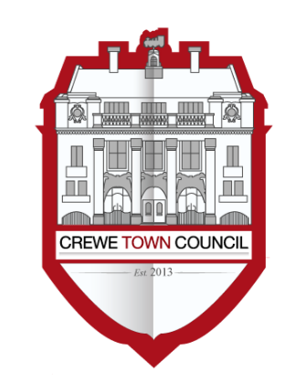
Crewe Town Council
Marketing and Events Committee
1 Chantry Court,
Forge Street,
Crewe,
Cheshire,
CW1 2DL

www.crewetowncouncil.gov.uk
Tel: 01270 756975

Minutes of the Meeting held on Tuesday 26th January 2021

This meeting took place on the Zoom platform due to the Covid-19 restrictions. The meeting was live-streamed on You Tube.

In attendance | Councillors Cosby, Dunlop, Faddes, Houston, Jill Rhodes, Straine-Francis
 | A vote of thanks was recorded to Edwina Rigby for her hard work and dedication.
20/04/01 | To receive apologies for absence
 | No apologies were received.
20/04/02 | To note declarations of Members’ interests
 | No declarations of interest were raised.
20/03/03 | Public Participation  A period not exceeding 15 minutes for members of the public to ask questions or submit comments
 | There were no questions or statements made.
20/04/04 | To confirm and sign the Minutes of the Marketing and Events Committee meeting held on Tuesday 10th November 2020
 | RESOLVED: That the Minutes of the previous meeting are approved and signed as an accurate record.
20/04/05 | To review the year-to-date financial position for the Marketing and Events Committee

The Marketing and Events Officer updated Members on the YTD financial position of the Committee.

Members noted the update.
20/04/06 | To receive and consider an update from the Events Officer with regards to the reviewed SpareParts’ proposal for trAction 2021 and the overall trAction 2021 event
The Events Officer briefed Members with regards to trAction 2021 and Spare Parts’ proposal.

Members noted the update.

RESOLVED: that the whole trAction event won’t be delivered this year in its original format, but will be restricted to the delivery of the SpareParts’ elements only. The decision is subjected to:

- The event being postponed toward the end of August
- The programming and delivery of the event being done in consultation with the Public Health Team in Cheshire East
- A revised agreement being signed to highlight liability and financial risks in case the event is postponed or cancelled due to the unpredictable COVID situation

Members indicated option 3 (trail) of the attached report as their favourite option.
20/04/07 | To receive an update with regards to the Ly2 project to improve the Lyceum Square in Crewe

The Marketing and Events Officer updated Members with regards to Ly2 project.

Members noted the update.
20/04/08 | To receive an update from the Events Officer on Lumen 2020 and the town Christmas lights display

The Events Officer updated Members on Lumen 2020 and the town Christmas lights display.

Members noted the update.
20/04/09 | To receive and consider the Procurement Return Report provided by Town Clerk’s for the appointment of an external agency, to progress the development and implementation of the Crewe Town Brand for Crewe Town Council and its assets

The Town Clerk updated Members with regards to the Procurement Return Report.

Members noted the update.

RESOLVED: based on the quotation received, Members resolved to appoint Design Office to progress the

development and implementation of the Crewe Town Brand for Crewe Town Council and its assets. It was agreed that the chosen agency is contracted to commence the design and implementation of the brand.
20/04/10 | To note that a Marketing and Events Committee Delivery Plan will be drafted for Members’ consideration and discussed in the next Marketing and Events Committee meeting

The Town Clerk briefed Members with regard to the item.

Members noted the update.
20/04/11 | To note the date of the next Marketing and Events Committee meeting: Tuesday 2nd March 2021
 | Members noted the update.

Meeting closed at 20:20hrs

Chair: Cllr Cosby

Clerk: S Garnero

