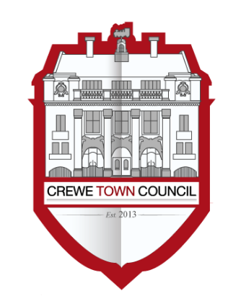
Crewe Town Council
Marketing and Events Committee
1 Chantry Court,
Forge Street,
Crewe,
Cheshire,
CW1 2DL

www.crewetowncouncil.gov.uk
Tel: 01270 756975

Minutes of the Meeting held on Tuesday 10th November 2020

This meeting took place on the Zoom platform due to the Covid-19 restrictions. The meeting was live-streamed on You Tube.

In attendance | Councillors Cosby, Dunlop, Faddes, Houston, Messent, Jill Rhodes, Straine-Francis
 | Also present was Cllr Walton
20/03/01 | To receive apologies for absence
 | No apologies were received.
20/03/02 | To note declarations of Members’ interests
 | No declarations of interest were raised.
20/03/03 | Public Participation  A period not exceeding 15 minutes for members of the public to ask questions or submit comments.
 | There were no questions or statements made.
20/03/04 | To confirm and sign the Minutes of the Marketing and Events Committee meeting held on Tuesday 8th September 2020
 | RESOLVED: That the Minutes of the previous meeting are approved and signed as an accurate record.
20/03/05 | To review the year to date financial position for the Marketing and Events Committee

The Marketing and Events Officer updated Members on the YTD financial position of the Committee.

Members noted the update.
20/03/06 | To receive an update with regards to the proposal from Blitz Fireworks to redeploy 290 meters of icicle lights and 4 Christmas motifs (Over-Roads) to new locations in the town centre
The Events Officer briefed Members with regards to the outcome of the discussion with Blitz Fireworks – that no action was to be taken due to cost implications.

Members noted the update.
20/03/07 | To receive and consider an update with regards to Lumen 2020 and the overall Lumen Programme

The Events Officer updated Members with regards to the Lumen Programme and the possible options in light of the current Government restrictions.

Members noted the update.

RESOLVED: to postpone the entire Lumen programme to Lumen 2021 (November 2021).

RESOLVED: that the Lumen budget (cost centre 352/4274) is earmarked to support the delivery of the event in November 2021. It was agreed also not to amend the Marketing and Events Committee draft budget 2021/22.
20/03/08 | To receive an update with regards to Lumen LightLab project

The Events Officer updated Members on Lumen LightLab project.

Members noted the update.
20/03/09 | To receive an update from the Events Officer on Remembrance Service 2020

The Events Officer updated Members with regards to the Crewe Remembrance Service 2020.

Members noted the update.
20/03/10 | To consider a change of format for the SpareParts delivery for Traction 2021 and to give a clear directive based on a draft programme proposal

The Events Officer briefed Members on the updated SpareParts proposal for trAction 2021

Members noted the update.

RESOLVED: that the SpareParts’s proposal will be reviewed later in January, in the understanding that will be updated with more options for Members to consider together with a clear draft programme.
20/03/11 | To receive an update with regards to the £750,000 awarded from the Town Fund to improve the Lyceum Square in Crewe

The Marketing and Events Officer updated Members on the item.

Members noted the update.
20/03/12 | To consider to approve the start of a procurement process for adopting the Crewe Town Brand as detailed in the report attached

The Town Clerk briefed Members on the item.

Members noted the update.

RESOLVED: that the procurement for adopting the Crewe Town Brand is approved, in the understanding that the chosen agency proposal will be considered and approved by this committee prior to implementation.
20/03/13 | To note the date of the next Marketing and Events Committee meeting: Tuesday 26th January 2021
 | Members noted the update.

Cllr Dunlop joined the meeting at19:09hrs
Meeting ended at 20:14hrs

