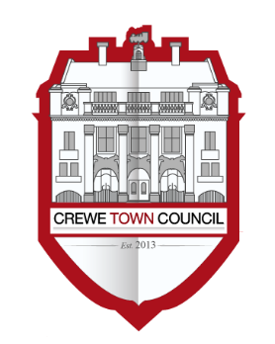
Crewe Town Council
Community Plan Committee
1 Chantry Court,
Forge Street,
Crewe,
Cheshire,
CW1 2DL

Tel: 01270 756975
www.crewetowncouncil.gov.uk

Minutes of the Meeting held on Monday 24th June 2019

19/2/01 | Present:-
 | Councillors Tess Buckley, Alan Coiley, Tom Dunlop, Hazel Faddes, Dorothy Flude, Tess Keefe, Benn Minshall, Phoenix Morrissey, Jill Rhodes and Nanette Walton
 | Apologies:-
 | Apologies for absence were received from Councillor Brian Roberts
 | In attendance:-
 | Hannah Marr (Community Engagement Officer at Crewe Town Council)
19/2/02 | To elect a Chair of the Community Plan Committee for the Council Year 2019 – 2020
 | Members resolved to elect Councillor Tom Dunlop as Chair of the Community Plan Committee for the Council Year 2019 – 2020
19/2/03 | To elect a Vice Chair of the Community Plan Committee for the Council Year 2019 – 2020
 | Members resolved to elect Councillor Phoenix Morrissey as Vice Chair of the Community Plan Committee for the Council Year 2019 – 2020
19/2/04 | To note declarations of Members’ interests
 | Councillor Dorothy Flude declared a non-pecuniary interest with regards to the Arts, Culture, Heritage and Leisure Action Plan in light of being the Chair of the Crewe Heritage Trust
19/2/05 | Public Participation
 | A period not exceeding 15 minutes for members of the public to ask questions or submit comments
 | Councillor Hazel Faddes highlighted the need to publicise the work of Crewe Town Council as much as possible
19/2/06 | To confirm and sign the Minutes of the Community Plan Committee Meeting held on Monday 20th May 2019
 | (minutes attached)
 | The Minutes of the Community Plan Committee Meeting held on Monday 20th May 2019 were approved by Members and signed as an accurate record by the Chair of the Community Plan Committee
19/2/07 | To receive a report related to the recent consultation carried out with the voluntary, community and faith sector to refresh the Action Plans contained within A Vision for Crewe – Crewe’s Community Plan
 | (document circulated)
 | Members received a report regarding the recent consultation carried out with the voluntary, community and faith sector to refresh the Action Plans contained within A Vision for Crewe – Crewe’s Community Plan
19/2/08 | To consider matters regarding to progressing the work undertaken via A Vision for Crewe – Crewe’s Community Plan
 | Members resolved to recommend to Council that the refreshed Action Plans are adopted and these form the basis of the work carried out via A Vision for Crewe – Crewe’s Community Plan
19/1/09 | To note the dates of future meetings of the Community Plan Committee:-
- Monday 15th July 2019
- Monday 9th September 2019
- Monday 4th November 2019
- Monday 27th January 2020
- Monday 23rd March 2020
 | Members noted the dates of future meetings of the Community Plan Committee
 | The Community Plan Committee Meeting closed at 7.39pm

A Vision for Crewe
Crewe’s Community Plan

Action Plan Refresh
June 2019

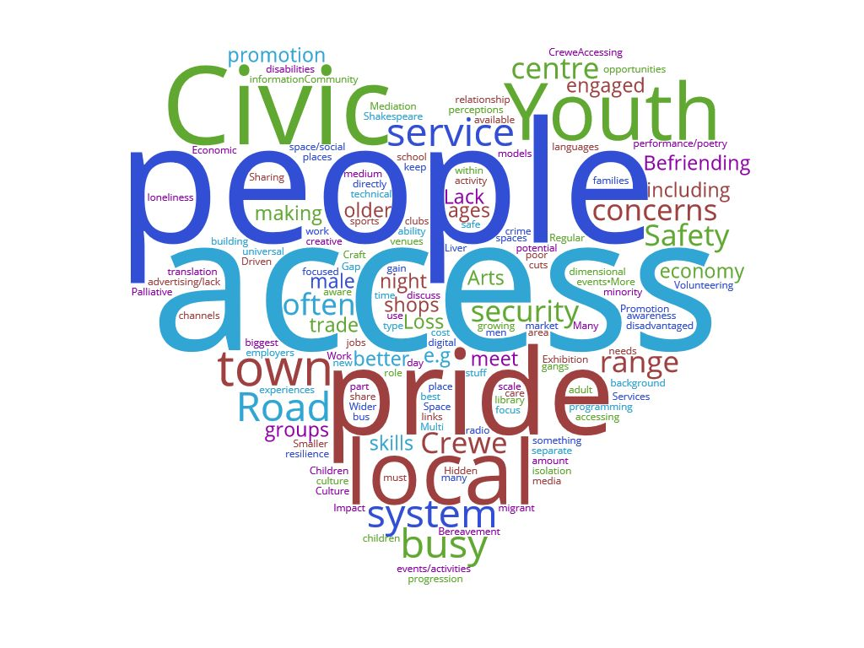

Executive Summary
Crewe Town Council is committed to working with its partners to provide unrivalled levels of community support which has been a key part the Council’s mandate; working hard to deliver and support a programme of diverse and inclusive activities based around agreed core themes. Ever evolving, the focus of the Town Councils engagement has been further developed following a consultation exercise in 2019 to refresh the Action Plans with the help of the community, voluntary and faith sector. This is reflected in the new proposed strategy for A Vision for Crewe – Crewe’s Community Plan, details of which are shared in the following pages

Background
Since its inception in 2013, Crewe Town Council has been developing its profile and has become very visible with its community engagement

In spring 2014, Members resolved to commission a Community Led Plan for Crewe by building an evidence base as a mechanism to engage with the local community

Following a 12 month stakeholder engagement programme and public consultation process, five key topic areas immerged:-
- Arts and Culture
- Health and Wellbeing
- Housing
- Town Centre
- Young People

During the final stages, Draft Action Plans were presented to local community organisations for comment and to build relationships which had begun to form during the process. This was then followed by a town centre based Community Day held in March 2015 to formally unveil A Vision for Crewe – Crewe’s Community Plan to the public

In September 2015, a Community Engagement Officer was employed to further the Town Council’s community engagement and facilitate the delivery of the Community Plan

Over the last four years, work has taken place on wide range of activities in the community focussing on Arts, Culture, Leisure and Heritage, Young People and Health Wellbeing. Issues covering the Town Centre were later picked up once the Town Centre Projects Officer was employed in 2017

A prodigious amount of time has been spent to meet with key individuals, stakeholders and organisations to nurture a broad network of community partners which became known as the Vision for Crewe Network. This has included a mix of front line staff, managers and volunteers as well as organisations which are vastly different in constitution, size, experience and interests

It became quickly apparent that there was a lack of opportunity for community partners to communicate with one another and to share knowledge, skills and best practice in order to build common interests. Local networking had been badly affected by wider structural changes in public funding and community / voluntary sector structures. Those working in the Health and Wellbeing sector have particularly seen an unprecedented level of change as community partners were delivering more services, for less income every year. This has had a detrimental effect on the capacity for local community sector organisations to network as the emphasis had to be more on their day-to-day delivery on the frontline

A large Focus Group was established which met quarterly to support community partners to meet in a neutral but productive environment which became intrinsic to enabling them to network and form partnerships. The Group set its definition as:-

Working together to support people to achieve their potential in terms of
socially, emotionally, mentally, physically, intellectually and spiritually

The Group saw all their activities as interdependent; as one Group helps someone in the community, that person is changed and therefore how they interact with other services may differ or change also. The Group felt their work was best described as a jigsaw (see below), each piece is interconnected to others and is vital in providing a complete picture

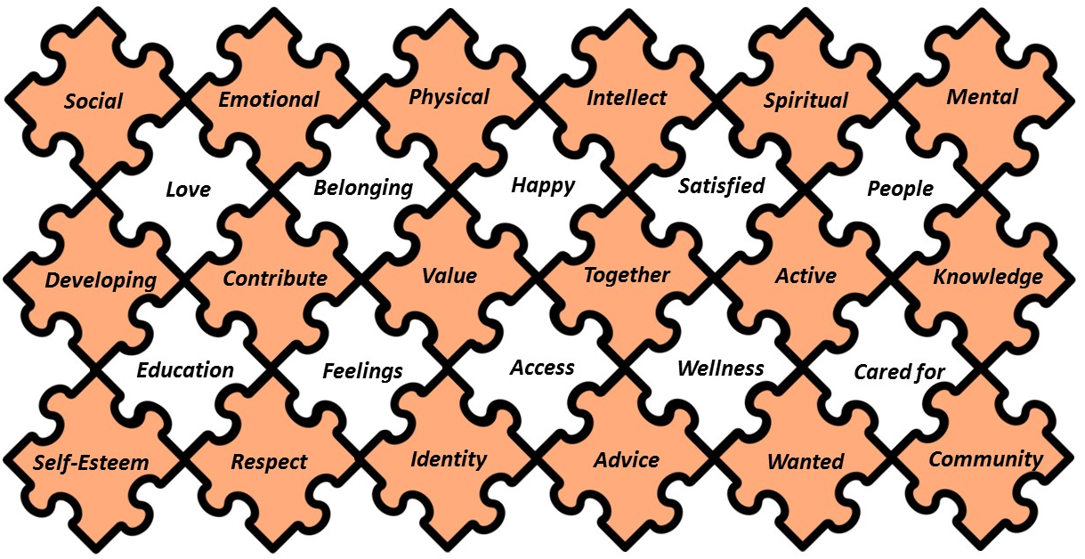

Overall Definition
During the First Year Review in 2016, the definition of what ‘A Vision for Crewe – Crewe’s Community Plan’ aimed to achieve was established as:-

Enable, influence and broker opportunities to enhance the quality of life for the people of Crewe

The following three terms describe the approach taken as the Town Council aims to not work in isolation, but rather through constant and continued dialogue with stakeholders and community partners:-

- We enable our community partners and residents to enhance their community by sharing resources through funding, time and gifts in-kind, skills sharing, hospitality, authorising access and much more besides;
- We influence community development by building relationships of mutual trust with community partners, supporting and nurturing ideas and projects, mentoring community partners, planning and promoting community activities and sustaining a large network of organisations operating under the voluntary, community and faith sector umbrella;
- We broker opportunities by using the Town Council’s unique position to connect community partners together to work more efficiently and productively to share knowledge and skills to facilitate positive locally based activity;

Through proactively engaging with current community partners, building new contacts and consistent networking, the Community Engagement Officer has acquisitioned a wealth of knowledge and connections across a number of topics which are deployed to advance the work undertaken by A Vision for Crewe – Crewe’s Community Plan and general community engagement on behalf of Crewe Town Council

Listed below are a few examples of ways in which the Community Engagement Officer has been able to enable, influence and broker community engagement in Crewe over the past four years:-

Enabling Role | Influencing Role | Brokering Role
- Developed and coordinated the giving of financial and practical resources  - Facilitated outside agencies to use community based assets and facilities  - Provision of rapid responses to activities and events to gain maximum engagement with organisations in the community  - Connected local media to agencies, organisations and services  - Facilitated the engagement from the Vision for Crewe Network with the Joint Strategic Needs Assessment  - Practical hands on support  - Assistance to manage projects  - Shared information, knowledge, advice and guidance  - Nurtured ideas, projects and initiatives  - Provision of high level professional support, predominantly on a one-to-one basis to harmonise cooperation between stakeholders and community partners  - Continued ongoing support to all community partners and stakeholders  - Continued ongoing partnership building | - Reached out to individuals and organisations by visiting, listening to and then introducing them to community engagement opportunities and partners  - Developed working relationships with local media to share stories and information on a regular basis on behalf of community partners  - Provide information, advice and guidance  - Formed support groups in response to gaps in provision / need  - Circulated information, knowledge and guidance throughout the Vision for Crewe Network  - Highlighted gaps in provision to community partners  - Built operational relationships with community partners to enhance trust and partnership working in the community  - Signpost and match make community partners  - Organisational mentoring support  - Pump primed / seed corned multi-partner projects and initiatives designed and managed with a partnership approach  - Continued ongoing partnership building | - Developed a large number and wide range of local initiatives and projects  - MMU Work Placements  - Crewe Women’s Day  - JSNA research and information gathering sessions  - Community Days  - Information gathering on behalf of the NHS and CCGs  - Administration and circulation of information across the Vision for Crewe Network  - Constant ad hoc sharing of ideas, information and knowledge to community partners  - Received external enquires and then directed / signposted to the right community partners  - Written statements / press releases on behalf of projects and then liaised with local media to support the promotion of that activity  - Act as a first point of call / liaison to and between community partners for mentoring support  - Provided a platform for a large number of voluntary, community and faith sector organisations to engage impartially to share opportunities / resources / knowledge across a wide range of themes and topics

A Vision for Crewe – Crewe’s Community Plan has become instrumental in facilitating and maintaining a vital connection between community partners in Crewe by supporting them to develop and improve the quality of life for local residents

Where are we now?
In 2018, the Town Council felt that the original overarching report written in 2015 was still relevant, but the Action Plans within each theme needed to be reviewed and updated. It was felt that A Vision for Crewe – Crewe’s Community Plan needed to be more agile and include more proactive steps to tackle current issues

The scope of the work undertaken by A Vision for Crewe – Crewe’s Community Plan has rapidly expanded over time and was recently broken down into the following headings to try demonstrate the breadth of the activities in which it is involved:-
- Arts, Culture, Recreation and Heritage
- Twinning and International Relations
- Health and Wellbeing
- Environment and Wildlife
- Young People and Families
- Educations, Training, Volunteering and Employment
- Homeless and Vulnerable People
- Supporting Community Organisations and Assets

The Town Council highlighted a need to understand what services were currently being delivered in the Crewe community and key gaps that needed plugging. By identifying these, the Town Council can then develop a refreshed Action Plan to help deliver a positive impact via the range of community engagement activities deployed via A Vision for Crewe – Crewe’s Community Plan

In January 2019, Crewe Town Council formed a partnership with CVS Cheshire East to undertake consultation and research to develop the new Action Plan and to carry out asset mapping of existing community facilities to support future Partnership Centres

The scope of the work included consultation and engagement work with:-
- Community, Voluntary and Faith Sector organisations operating in and supporting the community of Crewe
- Key Strategic Partners – Cheshire East Council, South Cheshire Clinical Commissioning Group, Cheshire Police, Cheshire Fire and Rescue, etc.

Approach taken
To produce the new Action Plan, the following activities were undertaken:-

- Development of an online survey to gather information which included questions around:-
- Current service provision
- A current and future gap analysis
- Community Asset Mapping

The survey was open for six weeks between 1st February and 15th March 2019 with 73 individuals completing the online survey representing a mix of statutory, voluntary and private sector staff and volunteers. Appendix One shows the full results from the survey

- Delivery of two focus group sessions to discuss in more detail the gaps in services and future support needs
The first focus group focused on voluntary and statutory sector organisations and was attended by 13 individuals representing 11 organisations

The second focus group was targeted at members of Crewe’s arts and culture sector and was attended by 9 individuals from statutory and private sector organisations

- Individual interviews
In order to ensure that everyone was able to feed into the process individual interviews were offered and three were undertaken two of these were follow up conversations from individuals that had completed the survey

- Desk based research was carried out to identify community venues and assets which could act as Partnership Centres to support and increase the delivery of local services

Results
In developing the new Action Plan, the comments and views from the survey, focus groups and interviews were collated to enable themes and trends to be identified

Each method produced a range of issues and possible approach for addressing these. However, these common themes were consistent across all three groups:-
- Employment support for young people to include building resilience and raise aspiration which includes young people with special educational and additional needs
- Improved cultural engagement was needed linked to both diversity and general culture and arts activities
- A general lack of civic pride within the community and the Town in general
- The community not being able to access information which therefore has the knock on effect of not being aware of what is happening, what is available to them and what they can access
- Uncoordinated strategies in organisations leading to duplication in services or missed partnership working
- Need to improve services for adults and young people with autism which includes awareness raising of autism
- Need to improve youth provision and offerings of safe places for them to go

The following two issues were raised through both focus groups as being a very important in the delivery of services to the community:-
- Keeping service delivery local and, where possible, building and retaining local knowledge and understanding and utilising local providers
- Services delivered within the community with providers taking the services to the community and not centralising them

From the results the following 5 themes were identified

Cultivating Civic / Community Pride
- Working to make a difference in the life of our communities and developing a combination of knowledge, skills, values and motivation to make that difference happen
- Creating opportunities for local people by enabling them to be engaged and be employed in the place they live

Celebrating Arts and Culture
- Supporting the expression of creativity and imagination of the community in Crewe

Aspirational Young People
- Ensuring that young people in Crewe have the opportunities, knowledge and skills to progress towards achieving and building aspirations

Health and Wellbeing
- Creating spaces and opportunities where people feel safe and well
- Improving health and wellbeing
- Develop existing services and new initiatives focussed on health and wellbeing
- Increasing access to services and their engagement within the community

A Voice for Crewe
- A strong Town Council engaging in constructive positive dialogue with community partners to lobby and influence for and on behalf of Crewe

Each theme is detailed in this report with outcomes and potential actions identified having been developed from the results of the consultation

During the focus groups, there was recognition that whilst the Town Council could take direct practical action on many areas that were raised, there were some areas where the Town Council would need to act in a lobbying and influencing role instead. These areas have been listed under the theme of A Voice for Crewe

There were comments through the survey and focus groups which related to the development of the town centre and housing developments. These issues have not been included within this Action Plan however they are being considered by the Town Council in other areas of its work and Committee Structure

The Golden Thread
Crewe Town Council plays a very vital role in the development of community engagement and development activities in Crewe and a golden thread that runs through all these themes is one of the Town Council being an enabler, influencer and broker

The abundance of success which has been achieved so far via the work undertaken by A Vision for Crewe – Crewe’s Community Plan is often down to the ability of the Town Council identifying the support needs of organisations / individuals and through the knowledge, experience, advice and guidance provided to them

By having a detailed knowledge of Crewe and an in-depth understanding of what is taking place within community as well as the organisations and services which support them, has meant the Community Engagement Officer has been able to:-
- Bring community partners together to share ideas, experiences and information to deliver their services effectively
- Guide and mentor organisations on how and where they are the best placed to engage with the community as well as other services and organisations
- Signpost onto specialist and expert advice, services and organisations
- Provide small amounts of seed funding to make projects happen and also sustain some temporarily whilst other funding is being sought
- Constant and continued building of partnerships out in the community
- Enhance, raise and champion the profile of community work across Crewe
- Provide small grants to support community activity and assets
- Commission and establish projects and support groups in response to areas of need or issues arising
- Procure items and equipment which organisations often struggle to find funding for or are unable to provide their service or activity without
- Provide a sounding board and resource for organisations to tap into when required
- Establish working groups in response to issues and needs
- Sustain a large network of organisations predominantly based within the community, voluntary and faith sector

Refreshed
Action Plan
Themes
June 2019

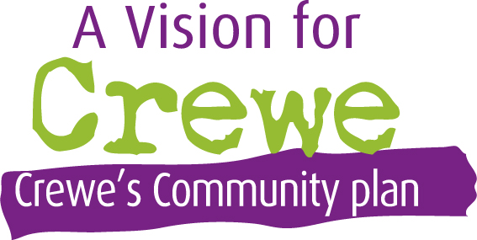
Cultivating Civic / Community Pride

Working to make a difference in the life of our communities and developing a combination
of knowledge, skills, values and motivation to make that difference happen

Creating opportunities for local people by enabling them
to be engaged and be employed in the place they live

Within the survey and focus groups, the theme of needing to improve civic / community pride came out strongly. There was a clear message that respondents felt action was needed to increase the amount of pride people had and exhibited in Crewe as the place they live, learn or work

The following Action Plan was developed to address the key issues and actions that were raised by respondents. They all aim to support the community to have the knowledge skills and opportunity to make a difference and develop pride within the community

Outcomes identified | Actions
Local services delivered at the heart of communities enabling local people to access support closest to them | - Work with the local community, voluntary and faith sector organisations and other key stakeholders to support and inspire:-  - The delivery of services through local community assets and partnership centres  - More joined up working to remove duplication and link services together in partnerships where possible  - Cultivation of a wide range of community events, projects, initiatives and activities using these to support the promotion of local activities, groups, organisations and services  - Development of community activities and services to support those with English as a second language  - Work with the business community in Crewe to engage all businesses, large and small, to effectively engage more with community activity, projects and initiatives
Creating a Voice for Crewe  Supporting Crewe to tell the best story about itself positively | - Building on the Crewe Branding Project, work with community partners to create a championing role to tell positive stories of Crewe and its community. Example activities could include:-  - Sharing the historic and current diversity of Crewe and its community  - Showcase local events and activities to tell the story of organisations, volunteers, services and the community  - Promotion of the voluntary, community and faith sector such as monthly themes promoting different organisations, services, topic areas, etc.  - Each Ward in Crewe has an identity or character which can showcase why it is unique and share this with the wider community
Supporting local people and businesses to be at the heart of service delivery | - Review how Crewe Town Council procures and commissions its activities to encourage community partners and businesses to do the same to:-  - Utilise local skills, knowledge and talents  - Where possible use processes which have social value to build and develop the skills and talents of the local community
Empower a volunteering culture within Crewe | - Campaign to promote a volunteering culture in Crewe and showcase the talents volunteers can bring, the benefits of volunteering and how it can enhance the community for the greater good  - Embedding Employer Supported Volunteering within local businesses and highlighting the positive impact this can have on businesses, employees, voluntary, community and faith sector organisations and the wider community

Potential Stakeholders that could support us to achieve our goals are:-
CVS Cheshire East  Cheshire Connect | Chamber of Commerce  Churches Together in Crewe | Cheshire East Council  CAT Radio

Celebrating Arts and Culture

Supporting the expression of creativity and imagination of the community in Crewe

Both focus groups identified the need for a strong Arts and Culture Sector within Crewe

There were two key elements with the first being artists themselves wanting to feel and be part of a vibrant sector in Crewe, have the workspace to inspire them and their work and also showcase those the local community

The second was the community being able to have a wide programme of arts and culture activities for them to engage with and enjoy. Where possible, there was a view that workshops / information sessions could support larger public events to give the community a greater exposure to arts and culture but could also play a part with smaller activities and also participate in services delivered at a local level

The following outcome and actions aim to provide the opportunity to celebrate arts and culture within Crewe

Outcomes identified | Actions
Having a strong and active Arts and Culture Sector in Crewe with the community engaging in arts and culture activities | - Build and develop a strong Cultural and Arts Network and Forum which could possibly build on the work started by the original Crewe CAN  - Cultivate a wide range of events, activities and projects which have an arts and / or cultural focus but wider topic reach  - Support the completion and delivery of the Crewe Cultural Strategy  - Support community partners on the creation of a cultural arts space to bring together creative arts within Crewe. The aim of this would be a dedicated space where ideas can be shared and different pathways / opportunities / initiatives can be explored and showcased  - Support community partners with the development of Christchurch particularly supporting and implementing ideas on how the space can be used in its current open air form and then once proposed plans are completed

Potential Stakeholders that could support us to achieve our goals are:-
Crewe Cultural Forum | Cheshire East Council | Crewe CAN

Aspirational Young People

Ensuring that young people in Crewe have the opportunities,
knowledge and skills to progress towards achieving and building their aspirations

Throughout all responses, there was an expressed need to encourage young people to have aspirations and to be given opportunities to develop the skills and knowledge needed to give them the best chance to achieve their aspirations

It was raised that when developing activities, that this should be inclusive of all young people including those with physical disabilities, special educational and additional needs

Providing activities for young people to take part in was also raised alongside the need for safe and accessible youth provision. There were also many comments around ensuring that any barriers to accessing provision and services were considered including working with parents or guardians to support them to encourage their children to attend activities

The following Action Plan aims to help raise the aspirations of young people in Crewe

Outcomes identified | Actions
Inspirational achievable employment support available for Young People which builds their aspirations and resilience | - Provide informal learning opportunities for young people in addition to formal learning strategies for example:-  - YMCA GLOW Academy which tracks young people’s non-educational learning and skills though an App  - Use football and other sports as a way of learning and building resilience e.g. Conflict Management. This can also support increasing outreach activities away from traditional leisure centre spaces into the community and localities  - Develop a local strategy to bring employers together to merge the gap between school and work by showcasing the opportunities available for young people such as apprenticeships and training  - Provide a number of creative development opportunities for young people which are not just one off events. Example:-  - Creative Arts – an event linked with follow up workshops with employers or skills development
Young people having safe activities and places they can engage with | - Work with community partners to identify and support the development of activities that are delivered in local venues and locations that young people are able to access and are safe environments  - Ensure these projects are also financially accessible for the young people and their families  - Support community partners and organisation to be sustainable to make sure that projects can continue to be delivered and are not just temporarily sticking plasters
Support those Young People travelling out of borough for education are engaged with their community in Crewe | - Make links with the out of area schools that Crewe young people are attending  - Explore ways to raise awareness with these families of local support groups and activities in Crewe can attend as it was raised that many of these young people have special educational and additional needs so miss out on local information as they are not educated in Crewe

Potential Stakeholders that could support us to achieve our goals are:-
Crewe YMCA  Everybody Sport and Recreation  Churches Together in Crewe | Crewe Pledge  Cheshire East Council  Family Ties CIC | Friends for Leisure  Cheshire Arts for Health  LoveCrewe

Health and Wellbeing

Creating space and opportunities where people can feel safe and well

Improve health and wellbeing

Develop existing services and new initiatives focussed on health and wellbeing

Increasing access to services and their engagement within the community

Health and wellbeing of the community was identified through the survey and focus groups with issues raised around healthy eating, the impact of loneliness and isolation, the need for mental health services for adults, children and young people and the overall poor health outcomes in Crewe

The issue of transport was raised throughout all the themes but has been included in this section as it was often linked to the issues of isolation and accessing health and wellbeing services

The following Action Plan aims to highlight how working with community partners can improve health and wellbeing of the community

Outcomes identified | Actions
Reduce social isolation and loneliness in the community | - Support, encourage and develop projects and activities that promote companionship and befriending schemes  - Review existing transport services to identify where the gaps are and support local Community Transport schemes that can target those most in need and the timings for the activities they want to access
Improve the health and wellbeing outcomes of the community promoting self-care and healthy eating | - Work with community partners to support the promotion of health and wellbeing campaigns, initiatives, projects and services  - Support, encourage and develop health and wellbeing projects and activities with community partners that enable the local people to be more active, eat healthily and embolden self-care. Examples could include:-  - Projects, activities and initiatives outdoors, in safe environments and locally to those accessing them  - Peer Support / Self-Help groups focusing on specific and generic health and wellbeing conditions
Support available for adults, young people and children with mental health conditions | - Research potential schemes / projects which could be delivered alongside commissioned schemes / services which bring added value and meet any gaps in these services. Examples could include:-  - Mental Health Cafés  - Art and culture activities to support exploring mental health  - Sport, leisure and recreational activities  - Social Prescribing Projects

Community having access to support and advice on their finances which enable them to live well and access local events and activities | - Work with community partners to promote and develop services which provide financial planning, budgeting and support for individuals and families
Community feeling safe when accessing the town and services | - Work with community partners to promote community safety by delivering activities which empower people and help them feel safe and confident when travelling around the town in which ever form they choose or use  - Work with the community partners to identify and address areas with specific safety / anti-social behaviour concerns
Increase in bereavement services available in Crewe | - Work with community partners to explore the development of bereavement support groups and related activities within Crewe that are accessible to all

Potential Stakeholders that could support us to achieve our goals are:-
Cheshire Arts for Health  Friends for Leisure  Clinical Commissioning Groups  Christians Against Poverty  Cheshire East Council  Orbitas | Cheshire Police  Existing Transport Schemes  Churches Together in Crewe  LoveCrewe  Everybody Sport and Recreation  End of Life Partnership | Citizens Advice Bureau  Cheshire Neighbours Credit Union  Local Foodbanks  Cheshire and Wirral Partnership  St. Luke’s Hospice  Crewe YMCA

A Voice for Crewe

A strong Town Council engaging in constructive positive dialogue with community partners
to lobby and influence for and on behalf of Crewe

This section includes key issues Crewe Town Council may not be able to directly address but has a role to play in lobbying and influencing partners and stakeholders representing the views of the community

Priority areas | Influential Key Stakeholders
Support available for adults, young people and children with mental health conditions and / or health conditions | Cheshire East Council  Clinical Commissioning Groups  Cheshire and Wirral Partnership  Local Member of Parliament
Young People travelling out of borough for educational purposes are not engaged with their community in Crewe | Cheshire East Council  Clinical Commissioning Groups  Local Member of Parliament
Actively responding to national and local consultations carried out by partners to represent the views of the community in Crewe | All Stakeholders
Transport infrastructure improvements | Cheshire East Council
Acting as Crewe’s biggest and best ambassador. Within this area potential activities include:-  - Councillors having a clear and defined role in promoting Crewe  - Working closely with recipients of grants, funding and support to promote the impact and benefits of the funded activities  - Identify areas of joint working | Crewe Town Council

Appendix One
Results from Online Survey

Through your knowledge and experience of the Crewe community,
what do you think are the key issues?
Word cloud showing the responses

Through your knowledge and experience of the Crewe community,
what do you think are the key issues?
Word cloud showing the responses

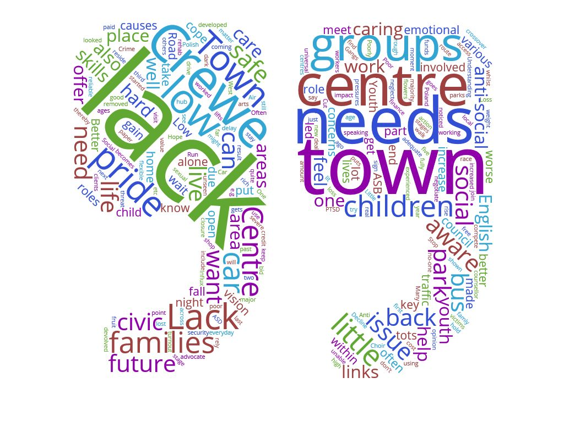

Other (please specify)
There are lots of organisation but not working together
Some, but not many
CVS Cheshire East and Crewe Town Council
There are too many organisations with overlap and duplication, which does not provide positive outcomes for the Community as a whole
We are designing some projects to address some of these issues, as are other organisations that we are aware of
awaiting a new town centre development to also support mobility issues
Plans have been in place for some years now but no development happening
There are many organisations aiming to improve the outlook in Crewe and providing much needed services, but there is much more that can be achieved. Austerity measures have not helped, with resources being cut, forcing more people into seeking help
I have limited knowledge of issues in Crewe apart from the ones we try to help with
Yes, we are aware. Also the distinction between CTC and CEC. Improvements and developments are not evident in any of these areas though, irrespective of whom is working towards improvement
Yes, we are, but we struggle to get funding because counselling in school time is seen as a statutory service

What do you think needs to happen to fill the gap and who needs to be involved?
Word cloud showing the responses

