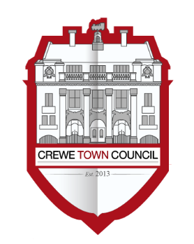
Crewe Town Council
Community Plan Committee
1 Chantry Court,
Forge Street,
Crewe,
Cheshire,
CW1 2DL

Tel: 01270 756975
www.crewetowncouncil.gov.uk

Minutes of the Meeting held on Monday 29th March 2021

CP20/5/01 | Present:-
 | Councillor Tess Buckley, Alan Coiley, Tom Dunlop, Jill Rhodes, Dennis Straine-Francis and Nan Walton
 | Apologies:-
 | Apologies were received from Councillor Benn Minshall
 | In attendance:-
 | Hannah Marr (Finance and Engagement Manager) and Pete Turner (Town Clerk)
CP20/5/02 | To note declarations of members interests
 | No declarations of members interests were received
CP20/5/03 | Public Participation
 | A period not exceeding 15 minutes for members of the public to ask questions or submit comments
 | No questions or comments were submitted to the Community Plan Committee by members of the public
CP20/5/04 | To confirm the Minutes of the Community Plan Committee meeting held on Monday 18th January 2021
 | The Minutes were approved as an accurate record
CP20/5/05 | To note the year to date financial position for the Community Plan Committee
 | The financial position was noted
CP20/5/06 | To consider matters related to supporting the Crewe Community First Responder Service
 | It was resolved to allocate funds of £3,000 to the Crewe Community First Responder Service
CP20/5/07 | To consider matters related to the Community Plan Business Delivery Plan for the forthcoming financial year 2021 / 2022
 | It was resolved to recommend to Council that the Community Plan Business Delivery Plan be approved
CP20/5/08 | To consider matters related to applications made to the Crewe Town Council Grants Scheme from:-  - Organisation: Cheshire Down Syndrome Support Group  Project Title: Online Dance Activity Sessions  Amount Requested: £980.00  - Organisation: Survive  Project Title: Facility Renovations  Amount Requested: £1,944.95  - Organisation: Child Safety Media  Project Title: Crewe Crucial Crew  Amount Requested: £2,500.00  - Organisation: Creative Action Team  Project Title: This is Me!  Amount Requested: £2,000.00
 | It was resolved to allocate funds of £980.00 to the Cheshire Down Syndrome Support Group
 | It was resolved to allocate funds of £1,944.95 to Survive
 | It was resolved to allocate funds of £2,500.00 to Child Safety Media
 | It was resolved to allocate funds of £2,000.00 to the Creative Action Team
CP20/5/09 | To note the dates of future meeting of the Community Plan Committee:-
- Monday 17th May 2021
- Monday 12th July 2021
- Monday 11th October 2021
- Monday 17th January 2022
- Tuesday 29th March 2022
 | Members noted the dates of future meetings of the Community Plan Committee
 | The Community Plan Committee Meeting closed at 7.29pm

