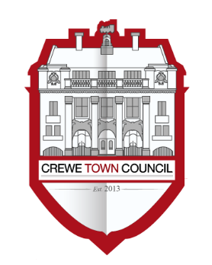**Crewe Town Council**

**Community Plan Committee**

1 Chantry Court,

Forge Street,

Crewe,

Cheshire,

CW1 2DL

Tel: 01270 756975

[www.crewetowncouncil.gov.uk](http://www.crewetowncouncil.gov.uk)

**Minutes of the Meeting held on Monday 11th March 2019**

|  |  |
| --- | --- |
| **18/4/01** | Present:- |
|  | Councillor Suzanne Brookfield, Benn Minshall, Jill Rhodes, Brian Roberts and Simon Yates |
|  |  |
|  | Apologies:- |
|  | Councillor Pam Minshall and Diane Yates |
|  |  |
|  | In attendance:- |
|  | Hannah Marr (Community Engagement Officer) |
|  |  |
| **18/4/02** | To note declarations of Members’ interests |
|  |  |
|  | Councillor Brian Roberts declared an non-pecuniary interest in Item 9 (Minute Reference : 18/04/09) relating to the Cheshire Neighbours Credit Union in light of being a Member of the Cheshire Neighbours Credit Union Board |
|  |  |
|  | Councillor Jill Rhodes declared a non-pecuniary interest in Item 8 (Minute Reference: 18/04/08) relating to project with St. Andrew’s with St. John the Baptist Church in light of being a member of the congregation |
|  |  |
|  | Councillor Jill Rhodes declared an non-pecuniary interest in Item 9 (Minute Reference : 18/04/09) relating to the Cheshire Neighbours Credit Union in light of being a Member of the Cheshire Neighbours Credit Union Board |
|  |  |
| **18/4/03** | To confirm and sign the Minutes of the Community Plan Committee Meeting held on Monday 15th October 2018  ***(minutes attached)*** |
|  |  |
|  | The Minutes of the Community Plan Committee Meeting held on Monday 15th October 2018 were approved by Members and signed as an accurate record by the Chair of the Community Plan Committee |
|  |  |
| **18/4/04** | Public Participation |
|  |  |
|  | A period not exceeding 15 minutes for members of the public to ask questions or submit comments to the Community Plan Committee |
|  |  |
|  | Mr Jackson raised a question to Members of the Community Plan Committee regarding the Royal Arcade and Crewe Town Centre Redevelopment Project which was responded to by Councillor Suzanne Brookfield  Mr Jackson raised a further question regarding the geothermal project which was proposed for the Manchester Metropolitan University Cheshire Campus which was responded to by Councillor Brian Roberts  The Chairman of Crewe FC made a statement to Members of the Community Plan Committee in support of the organisations application to the Crewe Town Council Small Grants Scheme |
|  |  |
| **18/4/05** | To note the financial position of the Community Plan Committee  ***(document attached)*** |
|  |  |
|  | Members noted the financial position of the Community Plan Committee |
|  |  |
| **18/4/06** | To receive an update regarding the work undertaken by A Vision for Crewe – Crewe’s Community Plan  ***(document circulated)*** |
|  |  |
|  | Members of the Community Plan Committee were given an update regarding the undertaken by A Vision for Crewe – Crewe’s Community Plan since the last meeting of the Community Plan Committee on Monday 15th October 2018 |
|  |  |
| **18/4/07** | To note the establishment of a mental wellbeing project for young people in Crewe in conjunction with Cheshire Arts for Health  ***(document circulated)*** |
|  |  |
|  | Members of the Community Plan Committee noted the establishment of a mental wellbeing project for young people in Crewe in conjunction with Cheshire Arts for Health |
|  |  |
| **18/4/08** | To note the establishment of a community orchestral programme in Crewe in conjunction with St. Andrew with St. John the Baptist Church  ***(document circulated)*** |
|  |  |
|  | Members of the Community Plan Committee noted the establishment of a community orchestral programme in Crewe in conjunction with St. Andrew with St. John the Baptist Church |
|  |  |
| **18/4/09** | To note a report from Cheshire Neighbours Credit Union  ***(document circulated)*** |
|  |  |
|  | Members of the Community Plan Committee noted a report received from Cheshire Neighbours Credit Union |
|  |  |
| **18/4/10** | To receive a report from Crewe Lyceum regarding the recent Doodle Safari  ***(document circulated)*** |
|  |  |
|  | Members of the Community Plan Committee noted a report received from Crewe Lyceum regarding the recent Doodle Safari at Crewe Lyceum |
|  |  |
| **18/4/11** | To receive a report from YMCA Crewe regarding the Destinations Worker supporting the homeless in Crewe  ***(document circulated)*** |
|  |  |
|  | Members of the Community Plan Committee noted a report received from YMCA Crewe regarding the Destinations Worker supporting the homeless in Crewe |
|  |  |
| **18/4/12** | To consider matters related to the Crewe Verdun Oaks Project and Peace Day 2019  ***(document circulated)*** |
|  |  |
|  | Members of the Community Plan Committee considered matters related to the Crewe Verdun Oaks and Peace Day 2019 |
|  |  |
|  | Members ***resolved*** to support the Crewe Verdun Oaks Project and to mark Peace Day 2019 |
|  |  |
| **18/4/13** | To consider matters related to the Crewe Pledge  ***(document circulated)*** |
|  |  |
|  | Members of the Community Plan Committee considered matters related to the Crewe Pledge |
|  |  |
|  | Members wished to convey its congratulations to the Crewe Pledge on securing funds from the European Social Fund to develop activity across Cheshire and Warrington |
|  |  |
|  | Members ***resolved*** to create an earmarked reserve of £8,000.00 in the Community Plan Budget for 2018 / 2019 (Budget Line : 474 / 4995) towards Pledge related activity in Crewe |
|  |  |
| **18/4/14** | To consider matters related to twinning and international relations  ***(document circulated)*** |
|  |  |
|  | Members of the Community Plan Committee considered matters related to twinning and international relations |
|  |  |
|  | Councillor Simon Yates expressed a desire to attend the Liberation Day celebrations in Mâcon, France, at his own expense to act as an Ambassador for Crewe |
|  |  |
|  | Members thanked Councillor Yates for his offer of support and ***resolved*** that he could act in the capacity of Ambassador for Crewe |
|  |  |
| **18/4/15** | To consider matters regarding the 80th Anniversary of 95 (Crewe) Squadron Air Training Cadets  ***(document circulated)*** |
|  |  |
|  | Members of the Community Plan Committee considered matters relating to the 80th Anniversary of 95 (Crewe) Squadron Air Training Cadets |
|  |  |
|  | Members ***resolved*** to allocate funds of £1,680.00 towards the purchase of new Squadron Colours to mark the 80th Anniversary of 95 (Crewe) Squadron Air Training Cadets |
| **18/4/16** | To consider matters related to a community counselling project in conjunction with Supporting Wellbeing and Nurturing Strength (SWaNS) CIC  ***(document circulated)*** |
|  |  |
|  | Member of the Community Plan Committee considered matters relating to a community counselling project in conjunction with Supporting Wellbeing and Nurturing Strength (SWaNS) CIC |
|  |  |
|  | Members ***resolved*** to allocate funds of £3,000.00 towards the community counselling project which will be facilitated by Supporting Wellbeing and Nurturing Strength (SWaNS) CIC |
|  |  |
| **18/4/17** | To consider matters related to the Crewe Debt Centre facilitated by Christians Against Poverty (CAP)  ***(document circulated)*** |
|  |  |
|  | Members of the Community Plan Committee considered matters related to the Crewe Debt Centre facilitated by Christians Against Poverty (CAP) |
|  |  |
|  | Members requested that further information was obtained regarding the project which can then be presented for future consideration by the Community Plan Committee |
|  |  |
| **18/4/18** | To consider matters related to supporting a strategic investment plan for the St. Paul’s Centre  ***(document circulated)*** |
|  |  |
|  | Members of the Community Plan Committee considered matters related to supporting a strategic investment plan for the St. Paul’s Centre |
|  |  |
|  | Members ***resolved*** to allocate funds of £1,000.00 towards items which will support the strategic investment plan for the St. Paul’s Centre |
|  |  |
| **18/4/19** | To consider matters related to supporting an After School Club facilitated by YMCA Crewe in Crewe East  ***(document circulated)*** |
|  |  |
|  | Members of the Community Plan Committee considered matters related to supporting an After School Club facilitated by YMCA Crewe in Crewe East |
|  |  |
|  | Members requested that further information was obtained regarding the project which can then be presented for future consideration by the Community Plan Committee |
|  |  |
| **18/4/20** | To consider matters related to sponsorship towards:- |
|  |  |
|  | 1. Local Hero Awards 2019 2. Berries, Beans and Beer Festival 2019 3. Crewe Pride in the Park 2019 |
|  | ***(document circulated)*** |
|  |  |
|  | Members of the Community Plan Committee considered matters related to sponsorship towards local events |
|  |  |
|  | Members ***resolved not*** to allocate funds towards the Local Hero Awards 2019 |
|  |  |
|  | Members ***resolved not*** to allocate funds towards the Berries, Beans and Beer Festival 2019 |
|  |  |
|  | Members ***resolved*** to allocate funds of £750.00 towards Crewe Pride in the Park 2019 |
|  |  |
| **18/4/21** | To consider recommendations from the Grants Working Group in relation to applications submitted to the Crewe Town Council Small Grants Scheme submitted to the Town Council before Sunday 17th February 2019 |
|  |  |
|  | The Grant Applications which have been submitted are:- |
|  |  |
|  | 1. Crewe and District Bus Users Group – £1,000.00 2. World Project Management – £1,000.00 3. Crewe FC – £1,000.00 4. Berkeley Academy – £1,000.00 5. Migraine and Me – £996.70 6. South Cheshire Pensioners Association – £750.00 7. West Street Christian Fellowship – £1,000.00 8. Cheshire Academy of Integrated Sports and Arts – £1,330.00 |
|  | ***(grant applications circulated)*** |
|  |  |
|  | Members of the Community Plan Committee considered the applications submitted to the Crewe Town Council Small Grants Scheme before Sunday 17th February 2019 and:- |
|  |  |
|  | 1. Members of the Community Plan Committee supported the project in principle subject to further discussions with the Crewe and District Bus Users Group regarding information contained within the grant application |
|  |  |
|  | 1. Members of the Community Plan Committee requested that further information is added to the Grant Application submitted by World Project Management which is then to be presented at a future meeting of the Community Plan Committee |
|  |  |
|  | 1. An award of £1,000.00 was ***resolved*** to be made to Crewe FC from the Crewe Town Council Small Grants Scheme |
|  |  |
|  | 1. An award of £1,000.00 was ***resolved not*** to be made to Berkeley Academy from the Crewe Town Council Small Grants Scheme |
|  |  |
|  | 1. An award of £996.70 was ***resolved*** to be made to Migraine and Me from the Crewe Town Council Small Grants Scheme |
|  |  |
|  | 1. An award of £750.00 was ***resolved not*** to be made to the South Cheshire Pensioners Association from the Crewe Town Council Small Grants Scheme |
|  |  |
|  | 1. Members of the Community Plan Committee requested that further information is added to the Grant Application submitted by West Street Christian Fellowship which is then to be presented at a future meeting of the Community Plan Committee |
|  |  |
|  | 1. An award of £1,000.00 was ***resolved*** to be made to the Cheshire Academy of Integrated Sports and Arts from the Crewe Town Council Small Grants Scheme |
|  |  |
| **18/4/22** | To consider matters related to the work undertaken by A Vision for Crewe – Crewe’s Community Plan under the themes of:- |
|  |  |
|  | 1. Arts, Culture, Recreation and Heritage 2. Twinning and International Relations 3. Health and Wellbeing 4. Environment and Wildlife 5. Young People and Families 6. Education, Training, Volunteering and Employment 7. Homeless and Vulnerable People 8. Supporting Community Organisations and Assets 9. Raising Civic Pride 10. Small Grants Scheme |
|  |  |
|  | Members of the Community Plan Committee considered matters related to the work undertaken by A Vision for Crewe – Crewe’s Community Plan |
|  |  |
|  | Members of the Community Plan Committee ***resolved*** to place the remainder of the Environment and Wildlife Project funds in an earmarked reserve for wildlife and environment projects in the town centre  Members of the Community Plan Committee ***resolved*** to place the remainder of Small Grants Scheme funds in an earmarked reserve for grant making purposes  Members of the Community Plan Committee ***resolved*** to place the remainder of the funds in the Community Plan Budget in an earmarked to be used to progress the work undertaken via A Vision for Crewe – Crewe’s Community Plan following the refresh of the current Action Plans |
|  |  |
| **18/4/23** | To note the date of future meetings of the Community Plan Committee as:- |
|  |  |
|  | * Monday 20th May 2019 * Monday 16th July 2019 * Monday 9th September 2019 * Monday 4th November 2019 * Monday 27th January 2020 * Monday 23rd March 2020 |
|  |  |
|  | Members noted the dates of future meetings of the Community Plan Committee |
|  |  |
|  | **Meeting closed at 9:15pm** |

Mental Wellbeing for Young People Project

Report to Community Plan Committee

Monday 11th March 2019

Who we are

Cheshire Arts for Health is a charitable organisation run by a board of six trustees who have a variety of backgrounds including; a hospital physician, a mental health practitioner, an artist with autism, a recovered substance misuse addict, accountancy and business management. We are currently in the process of transferring from being a charitable company to a Charitable Incorporated Organisation which will mean that we will receive a registered charity number which should be completed in January 2019. We have also been accepted as an approved supplier on Cheshire East Council’s Early Help Framework

We employ arts tutors / practitioners, counsellors and project staff on a sessional basis. We have a strong team of volunteers – around 20 at present

We run a vibrant community arts and wellbeing centre in Sandbach, which is a friendly, safe and supportive space, offering creative workshops, self-care programmes, peer support groups, wellbeing sessions for adults, teenagers and children

We run one to one sessions for young people with Autism, learning difficulties and severe anxiety

The facility is open six days a week and currently runs 15 group sessions per week, 5 specialist individual sessions and around 10 individual counselling sessions per week. This equates to approximately 100 people per week

We run specialist Arts for Dementia sessions out in the community. Volunteers run Sunday Socials, mainly aimed at middle aged and older adults, in an effort to reduce social isolation and encourage participation

We run and take part in community events and health projects in towns across South Cheshire. Two of our members are self-care champions and run information stands in supermarkets, GP surgeries and out in the streets. We chat about mental health (we are champions / ambassadors for Young Minds and Mind), coping with Dementia as a carer (all our volunteers are Dementia Friends)

We run outreach sessions at many other organisations in the area such as Friends for Leisure, Motherwell Crewe, Memory cafés in Alsager, Holmes Chapel and Congleton. Our volunteers run a children’s craft stall at the Sandbach Makers market and at the Rode Hall farmer’s market each month. This gives us good opportunity to chat to parents and to promote our services. We use these as fundraising opportunities

In the last year we worked face-to-face with more than 2,000 people from across Cheshire, enabling them to stay well and improve self-esteem

An important aspect of our work is our inclusive volunteering and training programme, which gives adults and young people the support and volunteering opportunities they need to help build confidence and new skills. We aim to help people reintegrate with friends, family and pursue education and employment opportunities

Many of our service users go on to do some form of volunteering for the organisation, quite often as either a way of *‘paying something back’* or needing a purpose in life, when there are few opportunities open to them, either due to illness or limited mental capacity

Our current strategic aims include increasing our geographical reach hopefully through community hubs

Who do we work with?

We work with:-

* Adults, young people and children with mental health issues;
* Adults with Dementia;
* Adults and young people with long term health conditions;
* Young people with autism, learning difficulties;
* Home educated children;
* Pre-school children at the libraries;
* Mums of young children (some of whom have mental health difficulties);
* Older adults who may become isolated;
* Peer support and focus groups for adults and young people (especially around mental health);

About our mental wellbeing project for young people in Crewe

This project aims to replicate a successful service started in Sandbach in September 2018. The project will provide support for young people, of high school age, experiencing emotional and / or mental distress who live in Crewe. The emphasis will be on early intervention to stop problems reaching crisis point, where there is a real danger of escalating anxiety, self-harm, becoming depressed / isolated and having suicidal thoughts

We work closely with the Connected Communities staff in Crewe to try and get involved in as many outreach programmes as possible in the Crewe area, especially with regards to young people. Staff have seen what we do in Sandbach and have indicated that this service is much needed in the Crewe area

In discussions with Cheshire East Council staff we have talked about finding a suitable venue and have been offered the use of the community hub building on Coronation Crescent in Crewe, which is ideal, as it is directly opposite Sir William Stanier School. The service will be open to all pupils from any of the Crewe high schools and will be promoted at each one. However, we are open to discussions on where best to place the service

When we did our research before setting up the service in Sandbach we talked to many high school pupils through events in the community and also campaign days in the schools (for instance a stall in the yard over a lunchtime to promote Young Minds and the work they do). We have also taken part in assemblies and organised joint ventures with the high schools

The young people start to recognise and trust us and are willing to offer their opinions and thoughts about what is needed to support their emotional wellbeing. One of the overwhelming statements we came across was the fact that they would not feel comfortable accessing counselling services or chatting to someone at school about their mental health due to what others might think. Unfortunately, there still exists a stigma around mental health and they stated that they didn’t feel it was always handled with sensitivity i.e. someone would walk into a classroom and announce that it was time for a pupils counselling session, in front of the rest of the class. Also if you were seen going to the counsellor that it might be viewed in a derisory way

Teachers have told us that some pupils do not want to go home as this is the cause of the problems. We see it as our job to build strength and resilience in that individual so they can cope better with the situation

Having interviewed a number of parents (including those who have pupils in Crewe high schools) the overwhelming message was that there is a lack of mental health services for young people in the area and of long waiting times for counselling, especially from CAMHS (Children’s and Adolescent Mental Health Services), to the point where some parents had been left with no option but to seek emergency care through A&E as problems had escalated. More than one parent described having been refused access to CAMHS as their child was not thought to be serious enough and then contacting CAMHS again when the problem had escalated and then told it was too severe for CAMHS now and to go to A&E

This project aims to address this need in the following way:

* To provide a suitable facility where young people can come together once per week after school to share experiences in a safe and confidential environment, away from the pressures of school;
* To provide professionally guided (although still ensuring that the sessions are person-centred) mental wellbeing sessions specifically designed for teenagers;
* To use all forms of the arts as a vehicle to aid relaxation, break down barriers and as a form of expression;
* To provide young people with the necessary tools that can be used in everyday life to help them cope better;
* Create a culture of ‘Can Do’ rather than a fear of failure;
* Assure individuals they are not alone, not *‘The Odd One Out’* and encourage individuality;

The sessions will be run by 2 qualified counsellors (who have experience in working with young people) and an arts practitioner. We have found that running the sessions with 2 counsellors, allows one to be with the group guiding the topic and one available for 1:1 counselling for any young person that feels they need it on that particular day

The session will run on the same day each week after school for 1.5-2 hours. The sessions will be free of charge, to ensure that cost is not a barrier to accessing the service. This is particularly important in Crewe as there are large areas of deprivation. There will also be food available at the session

Each young person will be given their own personal A5 sketch book / journal which they can do as much or as little as they feel comfortable. They will be encouraged to try lots of different art forms, with the emphasis on expression, self-belief, resilience and self-care. Away from the session, the journals will act as a reminder and also a place to make notes during the time away from the session

The topics discussed at the sessions are very much dictated by the young people themselves, ensuring that a person-centred approach is used

Young people will be asked to complete a nationally approved wellbeing questionnaire (Strengths and Difficulties questionnaire for 11 - 18 years old) which will be analysed and reported on each month. All data is anonymised in reports and storage of any data is conducted in line with GDPR

We will also ask the young people to complete a feedback form after attending a few times to ensure that we are picking up suggestions or criticisms about the sessions, environment, staff etc. We look at these as soon after completion as possible and implement any changes that are needed

The project will be setup, managed and reported on by a former NHS Public Health project manager

Why is the project needed?

There is a severe lack of, early intervention, mental health support in the area. If problems are tackled as soon as possible this has been shown, through national studies, to reduce the demand for GP appointments and hospital admissions

We take part in health and wellbeing fairs in local towns and listen to the concerns of parents around the mental wellbeing of their child and family pressures that have an impact on this

The sessions will accommodate up to 10 young people at any one time. There is no necessity for young people to commit to attending every week. There is no set course length. We promote person-centred support which means that the young people themselves dictate what they would like to talk about. We have found this works well and gives them control and opportunity to tell us what’s bothering them

Many of the problems the young people talk about are centred on the home / family life. Teachers and support staff have told us, through joint working groups with the schools, that some pupils just don’t want to go home – which is very sad. It is our mission to provide them with the skills to deal with these situations and how to look after themselves

We will let them know that they can ring the counsellors at any time. We have setup a separate mobile number for this project and have handed out hundreds of postcards with the information on. The counsellors are then able to do 1 to 1 counselling outside of the sessions as the need arises. We have been informed by the high schools that if the waiting time is long for school counsellors then pupils could be referred to us and we can recoup the cost of the counselling session through the school (pupil premium allocation)

Our counsellors are charging a reduced rate for their sessions, in an effort to ensure the project is viable and will be sustainable

As the Crewe Community Plan shows there are 22.9% (16k+) of people living in health deprivation in Crewe, compared to a National average of 19.6%

It also states that 3,225 children under 16 years are living in poverty (as at 2011)

The research done for the plan with the Youth Advisors questionnaire states that young people do not feel proud of their town and there is a perception that you have to leave the town to be successful in life. This in turn leads to low self-esteem and feelings of apathy

Our young people’s sessions focus on the good, and on building confidence in themselves and in their abilities to succeed

Through getting involved in Connected Communities events in Crewe for young people, we are starting to form a bond with young people and they can relate to our young artists running the sessions, as they have had their own difficulties. Especially in terms of low self-esteem and lack of confidence

It is hoped, through tackling problems early, that the number of young people accessing emergency care services will be reduced, which in turn will reduce stress on the family as a whole

Costings

|  |
| --- |
| Assuming 1 session per week, after school, for young people aged 11-18 years.  Sessions will last for 1.5-2 hours and run for 40 weeks of the year. |

|  |  |
| --- | --- |
| Item | Total Costs |
| Postcard and poster printing | £100 |
| 2 X Counsellor fees (£20 / counsellor. £40 per week)  40 weeks X £40 | £1600 |
| Arts practitioner (£20 / week)  40 weeks X £20 | £800 |
| Project coordinator (2 hours per week @ £10 per hour)  40 weeks X £20 | £800 |
| Refreshments (£5 per week)  40 weeks X £5 | £200 |
| Personal Journals  100 X £2.50 each | £250 |
| Arts materials  £10 per week X 40 weeks | £400 |
| Grand Totals | **£4,150** |

Note

Following a discussion with Members on Monday 4th February, the Community Engagement Officer and the Chair of the Community Plan Committee met with Cheshire Arts for Health where an offer was made to fully fund the project at a total cost of £4,150.00. Cheshire Arts for Health accepted this offer

A number of venues were discussed to ensure that the project it could be accessible for young people from The Oaks Academy, Ruskin Community High School, Sir William Stanier Academy, St. Thomas More Catholic High School, Crewe Engineering and Design University Technical College and Cheshire College – South and West Crewe Campus. Cheshire Arts for Health are working alongside the Community Engagement Officer to source an adequate location and to begin to establish the project in Crewe

An update will be presented to the Community Plan Committee at a future meeting

[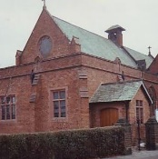](https://standrewscrewe.com/)Community Orchestral Programme

Report to Community Plan Committee

Monday 11th March 2019

St. Andrew’s Church on Bedford Street has met with Andrew Bassey the Music Director of Worleston Music School ([www.worlestonmusicschool.co.uk](http://www.worlestonmusicschool.co.uk)). His initial approach was for St Andrew’s to host an orchestral NHS benefit concert in February 2019 which the Church has agreed to and, as a gesture of goodwill and to support the event, they will be able to hire the Church building free of charge

Following on from those discussions, the Music School and Orchestra would like to provide three concerts across 2019 in St. Andrew’s Church with a varied musical programme – for example a Last Night of the Proms, a full choir and orchestral performance around Easter and perhaps a string quartet performance – which the Music School and Church aim to provide each concert completely free of charge to the community. Reverend Cullens who has worked as a Local Authority Arts Officer, understand that there is great enthusiasm for the arts in deprived communities but that money and affordability, especially for families, is a factor. Were the partners able to provide the concerts at no cost, they would begin to build a local audience for orchestral and classical music over the year which might then be taken forward with external art-based funding having shown the local appetite and need

The Music School has also been approached about as to whether they would be able to facilitate at least one lead-in workshop per concert either with a local school such as Pebblebrook or Vinetree or with the Little Fish Pre-School, whereby some of Andrew’s colleagues come along with instruments and allow children to engage with them and explain more about the concerts and give them a taste of how they might sound. These participants would then come to the concerts free of charge, thus taking away a major potential barrier to taking enthusiasm from these workshops forward. Andrew has also suggested that he would provide a mini Children’s Convert in the afternoon of each one, being perhaps half an hour, tacked on after our Saturday Café and to which families are invited

For the three concerts and including the workshops and mini children’s concerts Andrew has given a total fee of £1,500 and we would ask please a hire charge of £50 per time to cover costs. So our total grant bid is £1,650

We would therefore like to ask the Town Council to support this not only financially, but in terms of using the Vision for Crewe Network to publicise and raise awareness. This would be a ground breaking series of accessible, quality concerts with which we are able to bring orchestral music to a community where affordability for such an art form is very low indeed

Note

Following the discussion with Members on Monday 4th February, the Community Engagement Officer liaised with Reverend Lynne Cullen where an offer was made to fully fund the project at a total cost of £1,650.00. Reverend Cullens accepted the offer

Work has now begun on the project and an update will be presented to the Community Plan Committee at a future meeting

Cheshire Neighbours Credit Union

Report to Community Plan Committee

Monday 11th March 2019

1. Background

In September 2018, Cheshire Neighbours Credit Union gratefully received financial support from Crewe Town Council (CTC) amounting to £2,300. The aim of that financial support was to raise awareness of the Credit Union (CU) as many local residents were under the impression that the CU had ceased trading and as a consequence of this, membership and business was dropping dramatically and the Union was at risk of closure. The importance of raising the awareness of the CU could not be under estimated as future viability was questionable. All the Board Members resigned in April 2018 and a new Board was appointed. Promotion of the CU was vital and business growth was absolutely critical in order to retain a CU within the area

The purpose of this report is to provide evidence to CTC of (a) how the financial support had been spent, (b) the impact that this additional support has had on the business and (c) the current levels of performance

1. **How the money has been spent**

The focus has been twofold, firstly on raising the profile of the CU, getting the message out there to local residents that the CU is still in existence, and secondly on developing and promoting a range of products that are now available

Four separate publicity leaflets have been specifically targeted as follows:-

* **Child Benefit Leaflet**

This was suggested to us by Stockport CU where it had been exceptionally successful. We posted 5,000 leaflets through the doors in targeted areas of Crewe from October / November 2018, these were Barnabas Ward, Crewe South and Crewe Central. This leaflet promoted Christmas loans secured through the deposits of child benefit into accounts that also provided a savings element as well as paying back the Christmas loan

* **Jam Jar Accounts**

These leaflets continue to be delivered to the above wards but with the inclusion of Crewe East. This is a budgeting account where all payments are taken out of the account before the remaining money is released to the account holder. CU pays the landlord, council tax, etc. on behalf of the member. We have also promoted this facility to social housing providers

* **Landlord Leaflet**

Where the money is locked down and rent is paid direct to landlords. Promoted to letting agencies, employment agencies so that wages can be paid directly into account and to social housing providers

* **Tenant / Rent Payments**

This is similar to the landlord leaflet but is promoted to the tenant. It clearly offers more security to the landlord that rent will deducted from income

In addition to the leaflets, we have also attended a range of community events at the Salvation Army; Lifestyle Centre; South and West Cheshire College. The Operations Manager has also targeted Connected Community Hubs and is training the staff at the Hubs to promote the CU and assist potential customers to complete the application forms. The Community Hubs are provided with a portfolio of products and a range of the advertising leaflets. Furthermore, the Operations Manager is marketing the business to a range of businesses and employers in order to promote payroll deductions into bank accounts and bespoke loan packages

In October 2018, we invested in a new and improved database which provides a range of electronic support that we were hitherto undertaking manually, it is faster and more responsive to the needs of the CU. The CU also has a new website which is much more user friendly and works! We have a full range of information and all the products and application forms are available on the website. We also now have a very active Facebook page, which is *‘relevant’* with promotions targeted at the demographic that is most likely to require CU support

Through the new electronic promotions, we have recruited an additional 10 volunteers who have assisted in the delivery and development of the business. New ideas and new ways of working are being embraced. The working hours / working week have been expanded to include a full day on Friday (previously only open Monday – Thursday), this has been achieved through the recruitment of a part time customer service officer who is supported by volunteers

1. **Impact on the business**

The impact on the business has been very positive, with increasing numbers becoming aware that the CU is *‘open for business’.* There has been an increase in the number of customer contacts, which has created a more dynamic and vibrant atmosphere in the office. As mentioned, new volunteers and new trustees have been recruited with new and fresh ideas and expertise. The Operations Manager was appointed in September 2018 and a part time customer service officer appointed in February 2019; the staff roles have now been aligned and the business operates more smoothly, offering an improved customer experience. The loan application process is much speedier and the working week has been expanded. Customers can apply on line without the need to attend the office or use the postal service. In effect, CNCU banking services have joined the 21st century and offer a comparable service to other high street banks. We are consolidating our developments by networking with other local organisations, charities and businesses in order to get the message across and further develop the membership base. The more people in the connected community hubs that are trained to recruit new CU members, the better the growth potential

1. **Operational performance**

The full extent of the impact is yet to be felt as we only embarked on the developmental phase from October, once the operations manager was appointed and could lead the recovery plan. Here are some of the measurable figures, taken from our base point of August 2018 before we received the CTC funding, we also show our most up to date figures, as follows:-

|  |  |  |
| --- | --- | --- |
| Activity | August 2018 | February 2019 |
| Active savings accounts | 1347 | 1611 |
| Loans applied | 12 new applications  *(9 successful)* | 19 new applications  *(15 successful)* |
| Loans approved | £7,628.79  9 new loans  *(5 members topped up loans)* | £15,890.00  15 new loans  *(6 members topped up loans)* |
| Jam Jar budget accounts | 32 | 38 |

Additionally, we have an active Facebook page and for every post we share we expect to reach 10,500 people, with between 400 – 500 engagements. Both the volume of *‘reaches’* and *‘engagements’* are increasing all the time. We have every confidence that the business will continue to grow exponentially. The growth that has been evidenced above is really over a 4 month period and we anticipate that there is much more to be achieved

1. **Conclusion**

In conclusion, it is beyond doubt that CTC provided a lifeline to CNCU at a very critical stage in its developments. We at CNCU are of the view that we are on the right track, we know that there is so much more to do but at least we now have the right people and an improved set of tools to do it with. We remain optimistic that the CNCU can provide local people with a reliable and ethical money management option, and for good measure here is our recently agreed mission and vision

Thank you for Crewe Town Council support, it is very much appreciated

Sandra Link

HR Director and Secretary to CNCU Board

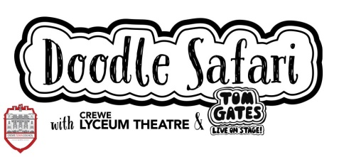Crewe Doodle Safari

Report to Community Plan Committee

Monday 11th March 2019

Doodle Safari Trail

Doodle Safari was a free half term activity open to all young people in Crewe, specifically targeted at primary aged children. Inspired by the show “*Tom Gates: Live on Stage*!” playing at the Crewe Lyceum Theatre from 27th February to 2nd March, we used the *‘doodle’* style artwork from the original book series as a starting point

The Doodle Safari activity created a trail round Crewe, encouraging participants to visit key landmarks and complete a “doodle challenge” in each place. This allowed us to draw support and partner with local businesses and organisations, including:-

* Crewe Lifestyle Centre;
* Crewe Library;
* Waterstones;
* Rhode Island Coffee;
* Crewe Train Station;

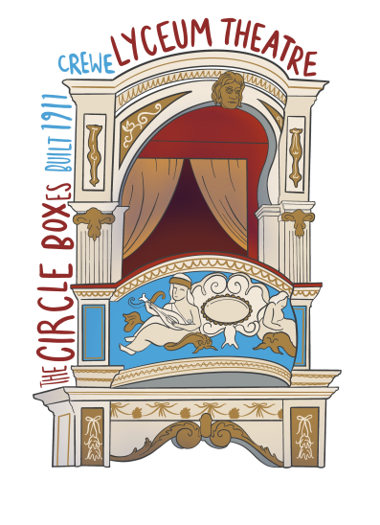Participants followed a specially created doodle map, which featured each of the stops and encouraged children to visit each to complete a doodle on the reverse of the map. The trail could be started and finished at any time during the half term week with a trail going in no particular order to offer flexibility to parents. The map also allowed us to advertise additional activity, such as workshops at the library and the workshops we hosted at the theatre with the support of Crewe Town Council

Doodle Workshops

As an additional free activity, support from Crewe Town Council allowed us to engage with local artist Jamie Neville, to run doodle workshops. These used the Doodle Your Town activity sheets that had been designed previously as a competition activity. The workshops encouraged families participating to find their creative style through doodling and draw a place in their town. We also opened the theatre auditorium for participants to complete their doodle challenge of drawing a piece of our theatre, inspired by Jamie’s drawings. The workshops were an hour long and took place on Monday, Wednesday and Friday of half term week

Aims and Objectives

The aims of the Doodle Safari workshop were to:-

* Offer a free activity for families to involve their children in during half term;
* Encourage young people to take part in a creative activity;
* Create an opportunity for young people to visit and explore our theatre;
* Encourage increased footfall and time spent in Crewe Town Centre;
* Increase civic pride by highlighting key Crewe landmarks;
* Advertise other activity going on during half term at other local sites, such as the Library;
* Build partnership relationships with local businesses and organisations locally the town;

The further aims of the workshops were to:-

* Encourage young people to take part in a creative activity, express their creativity and gain artistic skills and confidence;
* Engage with a local artist;
* Create an opportunity for young people to visit and explore our theatre;
* Increase civic pride by focusing on drawing parts of Crewe that people liked, enjoyed or were proud of;
* Increase our family engagement and promote our new Creative Learning and Engagement offer;

Outcomes

For Doodle Safari, we engaged with **107** young people who collected maps from one of the collection points

This included:-

* 55 from the Lyceum;
* 1 from Waterstones;
* 11 from the Lifestyle Centre;
* 40 from the library;

For the doodle workshops, we engaged with **82** people – 54 children / 28 adults over the course of 3 workshops. Wednesday was the busiest day, with 34 children and 18 adults visiting to take part in the workshop

Feedback was really positive, with many people saying how great it was to have fun and flexible activities during half term. Many drawings and doodles completed as part of the workshop were displayed in our Circle Bar as part of our Doodle Your Town display. Please see some of these pictures below

We also had great success working with local partners, all of whom have been very supportive and happy to work together again on future activity

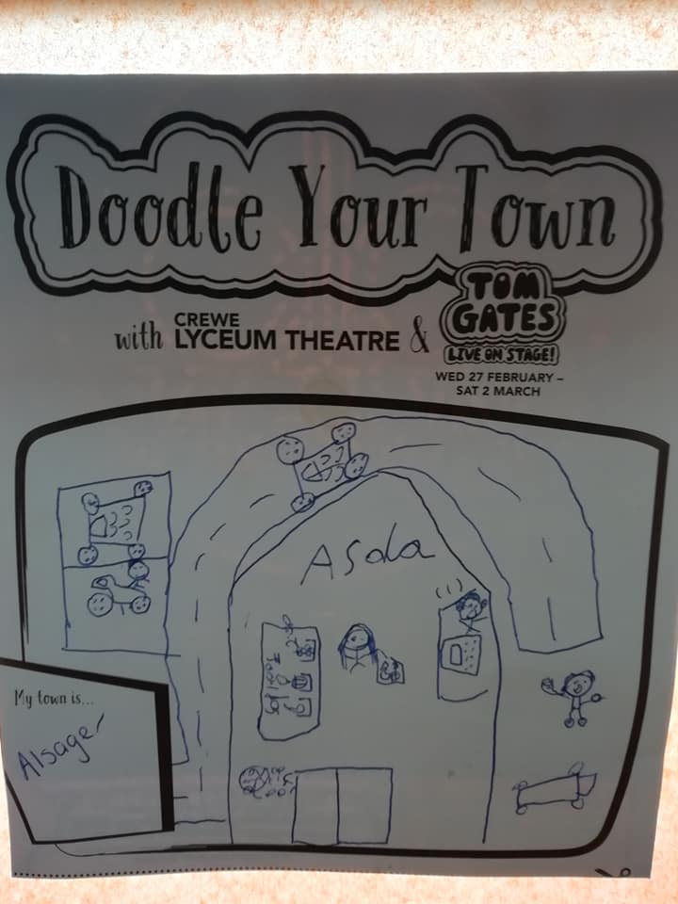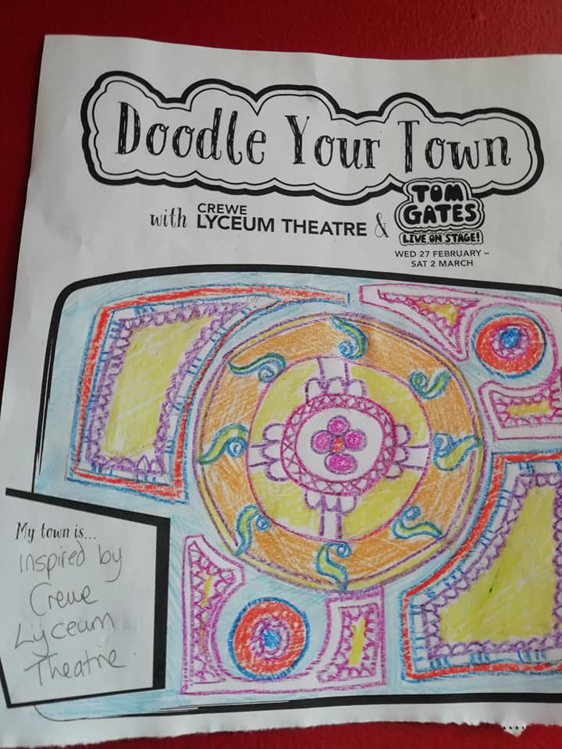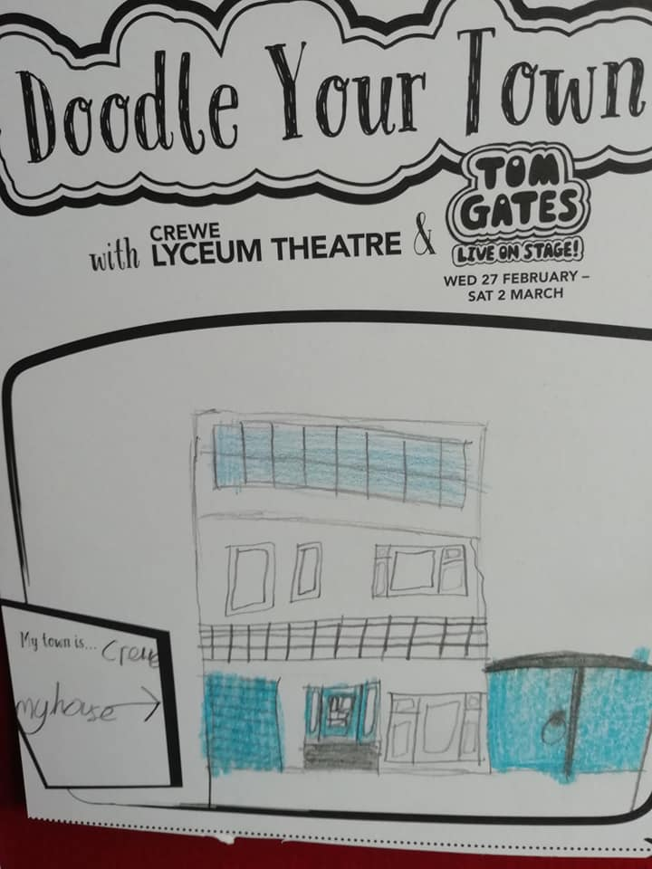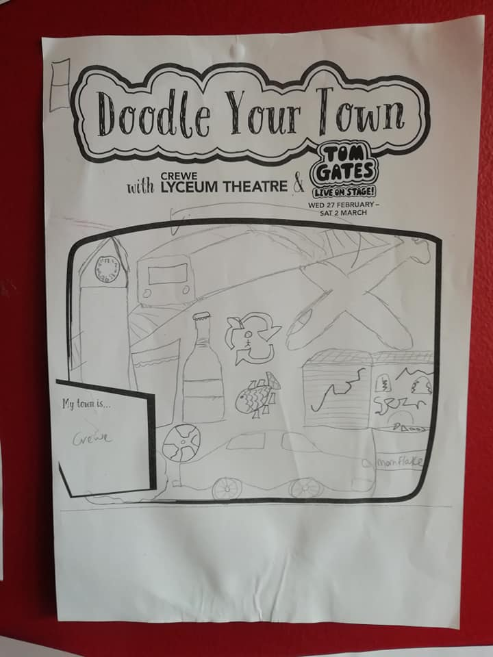

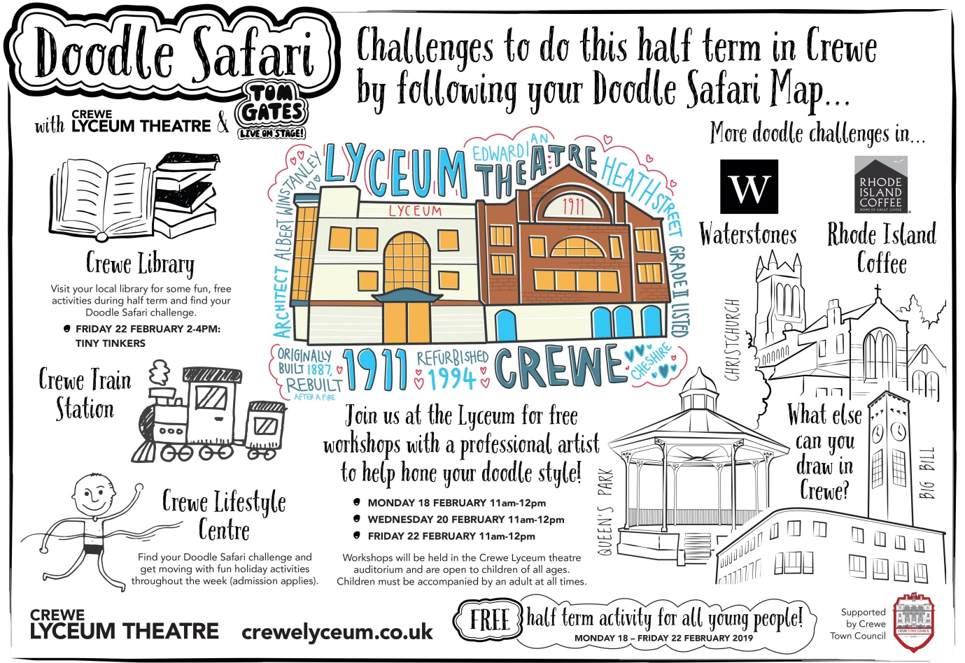

[YMCA England](https://ymcacrewe.org.uk/)Crewe Homeless Destinations Worker

Report to Community Plan Committee

Monday 11th March 2019

Crewe Town Council (CTC) have kindly contributed funded hours towards our Destinations Worker Lead, Kay Robaszek. The funds were focused on Kay carrying out outreach work to the harder to reach rough sleepers in Crewe. This was in recognition that strong individual casework was needed to seek to get people into accommodation or work was needed with people keep them safe if they decided to stay on the streets

Since the funding began further opportunities emerged for YMCA Crewe to secure resources to work with more individuals. This meant we could add value to the resource provided by CTC and to offer more emergency beds (through a Night Shelter) and to develop housing led placements (accommodation in the community with visiting support). Working with Cheshire East Housing Options (who secured funds from central government via a Ministry of Housing Bid) we have been able to reach more people needing the services on offer than ever before

Giving as rounded a picture as possible of the work of the last year which thanks to the contribution from CTC has helped to achieve, I would make the following points:-

* Our Outreach has extended to attending individuals sleeping on the street as we are contacted by any individual. YMCA Crewe regularly visit areas where we know rough sleepers are dwelling and we have been able to respond to people who would not present as homeless and support them to find housing;
* YMCA Crewe visits Drop In Centres regularly to meet with individuals and staff. All the daytime services provision have Kays contact number and have been advised on the process needed to trigger a call out or referral;
* YMCA Crewe has increased the number of complimentary and funded bed spaces at Gresty Road;
* YMCA Crewe has opened an additional night shelter in Hungerford Road and this will currently remain open until 31st March (it may be extended further depending on funding). On any one night we are providing beds (in both Hungerford Road and at Gresty Road) for 18 or on occasion more people who are from or would have been on the streets;

YMCA Crewe’s most critical contribution is to work with people beyond their immediate needs which the Salvation Army, LATH, CHANCE, etc. do and to try and get them on a supported housing pathway as they leave the streets

We do not rest easy on our laurels over this complex and hard to estimate problem – but steadily there has been a real impact on the homeless community in Crewe. This was demonstrated by the evidence provided from a recent head count of rough sleepers across Crewe very early in the morning in January (4:00am). Of the 15 people identified, all were known to our Outreach Workers and had been offered / received support. During this period we have worked in close partnership with the Police Navigate Team, daytime providers and health services

We are still waiting to hear if there will be any further funding from April from Cheshire East Council to continue to meet the need for this type of work

However, the ongoing support from Crewe Town Council is very much appreciated and still needed

Richard Holmes

Development Worker

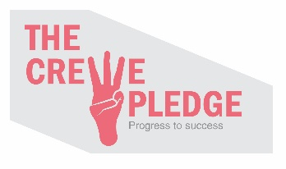The Crewe Pledge

Report to Community Plan Committee

Monday 11th March 2019

At the Crewe Pledge Management Board held on Tuesday 22nd January 2019, Trevor Langston provided an update on the ESF bid (European Social Fund) which is currently being processed by the DWP (Department for Work and Pensions)

Should the bid be successful, the operational element of Youth Federation will serve as the accounting body as they are approved to receive ESF monies; the Local Enterprise Partnership will serve as the delivery vehicle for all Pledge activity; which will in effect make *“The Pledge”* a *“Cheshire and Warrington Pledge”*

The *“Cheshire and Warrington Pledge”* will be underpinned by a Regional Board which will consist of representatives from 10 sub-regional Boards similar to The Crewe Pledge Management Board – except this could become *“The Crewe and Nantwich Pledge”*

Trevor Langston will sit as the Director of the *“Cheshire and Warrington Pledge”*; and would be directly employed by the Local Enterprise Partnership. There would also be a Youth Worker, who would operate one day a week and it is anticipated this would be Mark Waters. There will also be a number of Project Workers who would hold the responsibility for overseeing Pledge activity in *“patches”*; i.e. Crewe and Nantwich would have a dedicated Project Worker who would oversee all of the Pledge activity at local level

The target imposed by the ESF would be for the *“Cheshire and Warrington Pledge”* to connect 20 SMEs (Small – Medium Employers) with young people over 3 years – although The Pledge themselves will be aiming for a much higher number – but at present this is the only proven requirement

The DWP have requested additional information to support the ESF bid and indicated that they might look to issue a decision by the end of February

However, as of Monday 4th March 2019, no notification of a decision has been received

There is £8,000.00 allocated in the former Economic Development Budget for the financial year 2018 / 2019 which has been transferred into the Community Plan Budget. The recommendation to the Community Plan Committee is that these funds are placed in an earmarked reserve pending the outcome of the European Social Fund application

Twinning and International Relations

Report to Community Plan Committee

Monday 11th March 2019

In 2019, it is anticipated that international friendships and twinning – and indeed cultural cohesion / relations – will become the subject of much greater significance and focus moving forward. There have been a number of successful visits in previous years from our current international connexions and with recent developments, there is a potentially more strategic implications

Below are some examples of previous visits; as well as a number of wider initiatives which have been, or are beginning to be, undertaken: -

* Crewe and Mâcon, France: -
  + A visit from Crewe to Mâcon took place in May 2017;
  + A delegation from Mâcon visited Crewe in September 2017 where they were hosted at The Crewe Arms Hotel and Crewe Bowling Club. During this visit, Crewe Town Council worked with Crewe and Nantwich Twinning Association (CANTA) to organise the arrangements and assisted them with sourcing venues, activities, etc.;
  + Reciprocal visits between Crewe and Mâcon to mark the centenary of the end of the Great War in November 2018 when the Twinning Agreement was formally signed by both parties and incorporated a range of activities over the weekend which included a visit to Crewe Lyceum, attending the When the Lights Go Out Event and Remembrance Sunday;
* Crewe and Bischofsheim, Germany: -
  + In September 2016, a large delegation visited from Bischofsheim. With the aim of emphasizing our involvement in the community, the delegation attended a Community Day and BBQ at St. Andrew’s on Bedford Street where they mixed with the congregation and local residents and then moved on to Crewe Bowling Club for an afternoon of Crown Green Bowling. The following day, Crewe Town Council hosted an Afternoon Tea at Crewe Lyceum followed by afternoon of entertainment inside the theatre and then a guided tour of the building;
* Crewe and Dzierżoniόw, Poland: -
  + In September 2016, a small delegation from Dzierżoniόw joined the contingent from Bischofsheim and partook in the above arrangements;
  + Following discussions with a number of parties, Crewe Town Council was advised that the Polish were keen to find out more about the community in Crewe and develop social and information sharing links. Edleston Primary School was approached and pupils began a *‘Pen Pal Project’* where over 40 letters were sent to a school in Dzierżoniόw;
  + Discussions have taken place with a number of local community organisations and volunteers to establish other links and initiatives between Crewe based Polish residents including via student based projects through Cheshire College – South and West;

It is anticipated, where possible, that each town visits Crewe independently to enable each to have equal footing with an emphasis on activities and events being based within the Crewe community. Over the next two years, Members are asked to approve and note the following approach with regards to planned visits and events: -

* Mâcon, France
  + To accept a provisional invitation from Mâcon to send a delegation and Sports Team to participate in the Bastille Day ceremonies on 14th July 2019 as well as to witness the stage of the Tour de France starting in Mâcon on 13th July 2019. The Town Clerk has approached Crewe FC and Crewe Clarion to consider sending delegations and Crewe FC has shown willingness to host a four-way tournament in 2020 with Sports Teams from all twin towns;
  + Crewe FC have asked for financial assistance from Crewe Town Council to support their transportation to and from Mâcon for the visit in July 2019. Crewe FC have submitted a grant application;
  + To note the intention of the Town Clerk to participate in a charity bike ride from Crewe to Mâcon in July 2019;
* Bischofsheim, Germany
  + An invitation to a delegation from Bischofsheim is made to attend Remembrance Sunday 2019 with the anticipation that the new Friendship Agreement will be signed by both parties;
* Dzierżoniόw, Poland
  + An invitation to a delegation from Dzierżoniόw is extended for a visit in 2019 and another for Remembrance Sunday 2020;
  + To continue to nurture ideas and projects in the Crewe community with Polish residents and develop links with Dzierżoniόw;

In relation to cultural cohesion, Crewe Town Council is currently engaged in talks with Portfolio Holders at Cheshire East Council following the recent restructuring of the Communities Team. Below are some examples of those more recent developments which hold potential strategic implications for twinning and cultural cohesion: -

* The Cultural Cohesion Manager within the Communities Team has now left Cheshire East Council as a result of the contract reaching its end;
* The Cultural Cohesion Strategy, which is currently being developed by Cheshire East Council, and it has been discussed how Crewe Town Council can work with them in terms of the detail and timeframe for implementation of that Strategy;
* Encourage organisations such as Everybody Sport and Recreation and local community organisations to proactively engage more with other nationalities whom are known to be living within the community and access their facilities with the view to develop cohesion projects
  + To continue to nurture and develop engagement projects between the current and new twinning and friendship towns through building connections with the community, voluntary and faith-based organisations, schools and businesses in line with the principles and visions set out in the Town Councils Friendship and Twinning Policy;
  + A *‘Brexit – Know your rights!’* information session was held on 11th February organised in partnership with VESTA – Specialist Family Support CIC and the Salvation Army primarily focussed on the Polish community. Approximately 107 local residents attended and it proved very useful;
  + An approach has been made to run an additional *‘Brexit – Know your rights!’* session. It is anticipated that this session will be held in April 2019;

The emphasis should now be on Crewe Town Council to establish a much more structured and strategic approach to twinning and cultural cohesion which should seek to establish a regular calendar of events with Mâcon, France; Bischofsheim, Germany and Dzierżoniόw, Poland

It should also seek to determine what other nationalities reside within the Crewe community; as well as both identifying and maximising opportunities which will help to create deeper, richer and greater levels of integration

In the budget for 2018 / 2019, the allocation for twinning and international cohesion was set at £2,000; however, the majority of that allocation was utilised on hosting the visiting delegation from Mâcon in November 2018

The budget for 2019 / 2020 has sought to maintain the allocation of £2,000

If the aforementioned approach does gain approval from members, then this could have budgetary implications, and it may be the case that we look to draw from the General Reserves in order to support the Town Council in meeting the wider aspirations and objectives which might arise from a much more strategic approach being taken

[](https://www.google.co.uk/url?sa=i&rct=j&q=&esrc=s&source=images&cd=&cad=rja&uact=8&ved=2ahUKEwj_wc7R45DgAhXO1uAKHW7cDcAQjRx6BAgBEAU&url=http://www.crewelife.net/community-directory/95-crewe-squadron-raf-air-cadets/&psig=AOvVaw2x213G-kW3eC6GnnGa1LkX&ust=1548775270893354)95 (Crewe) Squadron Air Training Corps

Report to Community Plan Committee

Monday 11th March 2019

On 23rd March 2019, 95 (Crewe) Squadron will celebrate its 80th anniversary. The Unit was formed with 100 personnel as part of the Air Defence Cadet Corps to provide support to the defence of Crewe Works and Rolls Royce back in 1939. The Unit went onto become part of the Air Cadet organisation when that was formed in 1941, albeit its role to still support the air defence and educate young people on how to fly and conduct other RAF related roles

The Unit is also famous for being the first Cadet Band to perform on BBC Radio and the Co-op Band originated from former Cadets and Crewe Town Council has supported the Band to be reinstated over the last five years through grant funding towards new instruments

Over the years, the Squadron has supported many local charities, events, provided honour guards, corps of drums and made many other contributions to the local community

The Squadron would like to mark the occasion with an event which could possibly be held on Memorial Square, with both the Squadron Flag and RAF Flag on the flag poles. The event could include a parade which would likely include other Squadrons that were formed as detached flights from 95 (Crewe) Squadron including surrounding units such as Nantwich, Sandbach and Northwich. The parade through Crewe would follow the same protocol which set out for Remembrance Sunday – subject the relevant permissions being obtained – and could then be followed by a reception hosted by the Mayor of Crewe who would receive an invitation re-present the Colours in commemoration

95 Squadron would also wish to know of any adults who could potentially join as adult instructors – particularly female volunteers – as there is a shortage of female adult instructors

Following the discussion with Members on Monday 4th February, the Community Engagement Officer and the Chair of the Community Plan Committee met with Sergeant Chesters and Flight Lieutenant Lloyd. An offer was made to 95 (Crewe) Squadron that Crewe Town Council would contribute towards covering the cost of replacing the current Squadron Colours with new as those currently used are extremely fragile. An additional offer was also made to support the Squadron with their new digital archive, assist to collate stories from local residents who were part of the Squadron and also to publicise this milestone anniversary

95 (Crewe) Squadron accepted this offer of support and are currently obtaining quotes for the new Colours which are estimated to be approximately £1,000. Once this along with the estimated timescale it will take for the Colours to be produced has been received, a further meeting will be organised to develop the project and event further

[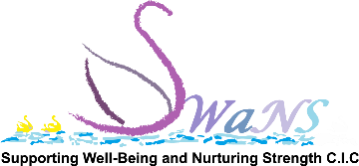](http://swanscic.org/)SWaNS Community Counselling Service

Report to Community Plan Committee

Monday 11th March 2019

Supporting Wellbeing and Nurturing Strength (SWaNS) CIC is a local not for profit organisation delivering counselling throughout Cheshire East but predominantly in Crewe. SWaNS deliver and supply programs and training based around emotional resilience and wellbeing, provide individual emotional support through counselling services and run emotional education and training days

Thanks to a grant from Crewe Town Council in February 2018, we have been able to deliver counselling specifically for Crewe residents thanks to a partnership formed with Cheshire and Warrington Carers Trust at Brierley Business Centre. Although we have been able to offer a very low cost service to the clients we have already seen, we have also received numerous enquiries from residents who are not able to afford even this small amount

With this in mind, we would like to request additional funding from Crewe Town Council which would enable SWaNS to provide a free counselling service to these potential clients who are struggling with their mental health and wellbeing

Through our work we have become aware that there is a severe lack of mental health support in the Crewe area. People are struggling to find appropriate services at a price they can afford, without an extremely lengthy wait, which is not conducive to addressing mental health difficulties appropriately and in a timely fashion. We have also been working with Alternative Solutions and have found that many of the clients they refer to us are unable to afford even low cost counselling and we are aware that this is the case for many other people in the Crewe area

The referrals will be from Alternative Solutions, Carers Trust, Motherwell and the general public will also be able to self-refer. We will also promote to Men in Sheds, Community Recycle Cycles and other such organisations to help address the shortfall in counselling services available for the male population

We have become aware of a paucity in the services for the male population in the area. For example, we have a good relationship with Motherwell who are well known for providing excellent support for mothers in the community. They have reported that fathers are also seeking suitable counselling support but are unable to access anything without an unreasonably long wait. We believe that support should be available at the time of need and not at some distant date in the future

Working on £3,000 we would be able to offer one initial consultation and five counselling sessions free to 20 people in Crewe who badly need the support

We have had excellent feedback from our existing clients who all report that they are highly pleased with our service, in particular the fact that we have been able to help them address their needs quickly. Clients have commented that they are now able to deal with issues in their lives more proactively, they have improved wellbeing and are now able to move forward positively

Bev Daniel, Clare Foster and Kirsty Halm

SWaNS CIC

St. Pauls Centre Strategy Investment Plan 2019 – 2022

Report to Community Plan Committee

Monday 11th March 2019

Introduction

In the coming months the team at St Paul's Centre will be seeking support to draw up a strategic plan for developing the site. After more than 30 years of servicing the community in numerous capacities, we have come to recognise the need to pass the baton for furniture reuse to another organisation. This will release capacity to pursue our other key project areas and, more importantly, open up St Paul's Centre to the wider community. We believe St Paul's Centre to be a community asset, in and through which many local groups and projects can find a home and the support to grow

Our current focus includes:-

* Undertaking the initial exploratory work to assess the viability of the furniture reuse project in light of external trends in furniture reuse charities locally;
* Exploring options for partnership / transition to another provider for furniture reuse;
* Producing a proposed 3D floor plan and a fly-by video plus a 3D image of our vision for a new entrance to St Paul's Centre;
* Completing the independent living training room in partnership with The Guinness Partnership;

Once we have these things complete we will move on to the second stage which will require more in depth analysis and significant funding. It is our intention to produce a strong case for support, and to take this out for funding from a variety of partners including crowd funding, trust funds and local businesses

Might we ask if Crewe Town Counsel could join us at this early stage by putting some funds towards the 3D floor plan and a fly-by video plus a 3D image of our vision for a new entrance to St Paul's Centre? We have appointed Wyvern Partnership LLP whose fee is £500 + VAT

Any contribution you are able to make at this time would be received with gratitude, and help form an important link between us in this venture

Every Blessing

Revd. Rob Wykes

Chief Executive Officer

**Support information**

St Paul's Centre has served the community of Crewe and Nantwich for more than 32 years. The centre has enjoyed being part of the community’s journey through the delivery of many practical projects. Situated on the corner of West Street and Hightown with easy access to the bus station and town centre, St Paul's Centre offers an open door to many of those in the community experiencing isolation or life on the margins of society

Founded in 1986 to serve the local community, St Paul's Centre is a place where people of all abilities thrive. Joining the team in 1996, Rob Wykes helped the charity begin a new journey towards the transformation of the building into a creative multi-purpose centre. Over the past 23 years, and in addition to infrastructure development funds, we have raised and managed 3.8 million pounds in running costs

Today St Paul’s has a new roof, is fully rewired and has a first floor. Part of the building known as John Ashe Hall has been completely renovated and now offers 6 start-up / business enterprise spaces and a conference room that seats 40 people whilst doubling up as a café on Fridays. The main building houses a cycle workshop, craft room, St Paul’s Pantry food bank, fully equipped training room, offices and storage facility. The charity has provided a supported working and learning environment for adults with additional needs since 1986. Today, up to 10 young supported adults form part of a wide team engaged in the charity’s practical activities

Over the years, St Paul's Centre has run a gardening business, a white goods refurbishment workshop, a computer literacy training centre, the Prodigals non-alcoholic youth event bar, the Kerith Crisis Pregnancy Counselling Service, a school uniform recycling shop, a woodworking and upcycling workshop, the Whole Child Project, the furniture reuse project, office services, Sustrans, Dial A Ride, young vulnerable adults support services, cycle reuse workshop, Enterprise Coaching service and John Ashe Hall conference room and desk space

The journey continues because we still have big exciting dreams for St Paul’s

At the core of the charity we seek to serve the community through the availability of the building. It is unique and offers a whole host of opportunities for local projects to find a home. ***Our vision for the coming three years is to open up the rear of the building as a new entrance, reshaping the centre to accommodate a cafe in the altar area and new rooms to provide space for other local groups and projects***. We specifically aim to support those facing and tackling isolation and marginalisation

Why a café in the altar?

In 2016 we opened a Friday café in John Ashe Hall – the results have been amazing. We have developed a group of regular service users and a number of them are offering to volunteer on other days of the week, were we to open more often. In addition to this, on 4 occasions since December 2018 we have turned customers away for shortage of space. So the café in the altar is a development and growth of an existing community café

Isolation and marginalization

St Paul's Centre is geographically central for folk across the Crewe area. It is easily accessed, with car parking for 500 cars near the new proposed entrance. It has been recognised that more and more people are affected by the challenges of Dementia, Alzheimer’s and isolation through age and infirmity. We aim to open up the centre for activities such as a Dementia Cafés, singing for the brain, creative arts

As a charity we plan to open up a new woodworking workshop and an upcycling project. The purpose of this is to broaden the practical opportunities local people will have to explore their creative side and meet people in a social setting. St Paul's Centre will also have a number of functional utilitarian rooms for hire, including a suite of counselling rooms, art studio, prayer room and bookshop

We are primarily focused on the local community and its development through transformation of individuals. Our aim is to facilitate other charities and small local groups as they stimulate a change in those they serve

Why invest in St Paul's Centre?

Investment in St Paul's Centre is to join with 32 years of successful fund management, 32 years of successful local project development, 32 years of practical sustainable community support. The team at St Paul's Centre have birthed, managed and successfully wound up many short-term funded projects, all with a 100% delivery outcome. We have managed this whilst continuing to maintain core activities over three decades

We have a track record which has stood the test of 5 Prime Ministers, 6 elections, 2 recessions and countless social policy redirections. Through all this, we remained faithful to the community of Crewe, servicing those most affected by change

St Paul's Centre is owned and managed by a team of 16 paid staff, a group of local trustees and over 30 volunteers





St Paul’s Centre, Hightown, Crewe, Cheshire, CW1 3BY

01270 586186 admin@stpaulscentre.org.uk www.stpaulscentre.org.uk VAT Reg No 932 9673 90