Crewe Town Council
Finance and Governance Committee
1 Chantry Court
Forge Street
Crewe
CW1 2DL

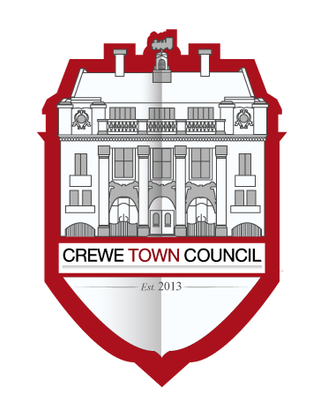

Minutes of the meeting held on Monday 16th September 2019

19/2/01 | Present
Cllrs Cosby, Dunlop, Jill Rhodes, John Rhodes, Roberts and Straine-Francis.

In attendance: Cllr Minshall, Steve McQuade (Town Clerk)

19/2/02 | To receive apologies for absence
 | Apologies were received and accepted from Cllrs Buckley, Flude and Messent.
19/2/03 | To note declarations of Members’ interests
 | Cllr Cosby declared an interest as his partner is Secretary to the Railway Cottages Residents Association.
19/2/04 | To confirm and sign the minutes of the meeting held on 1st July 2019
 | The minutes of the previous meeting were agreed as an accurate record and signed.
19/2/05 | Public Participation  A period not exceeding 15 minutes for members of the public to ask questions or submit comments  Representatives from the Railway Cottages Residents Association asked members for support and set out the context of their request for funding to enhance the heritage value of the Cottages.  Mr Mike Christelow also spoke in favour of supporting the Residents Association as a means of backing improvements in the town’s heritage.
19/2/06 | To review the year to date expenditure for the Committee and for Council as a whole and to review and consider debts to the Council
 | Members noted the information presented.
19/2/07 | To consider an update from the Leader in relation to strategic dialogue with Cheshire East.
Cllr Jill Rhodes provided the following updates:
- There is an expected meeting between respective Leaders in October.
- Dialogue has taken place with senior Managers supporting redevelopment projects in the town centre including the Royal Arcade.
- Dialogue continues on projects related to expenditure such as Future High Streets Funding.

19/2/08 | To consider matters related to the production of a strategic plan and the recruitment of a Proper Officer and RFO.
Members noted the report of the Clerk and agreed to recommend to Council that:
- The Clerk organise an opportunity for nominated members to meet prospective suppliers and for those members to appoint the chosen supplier to undertake both tasks or to split the work.

19/2/09 | To consider issues related to the Clock Tower (Big Bill).
Members recognised the public’s concern over the future of the clock tower and agreed that:
- The Clock should be preserved and ideally appropriately reused as soon as possible.
- Council supports the transfer and storage of the valuable heritage elements of the clock such that they can be safely stored with the Heritage Centre.
- Council expects that Cheshire East will manage the transfer of the heavy items making up the clock to the storage facility at the Heritage Centre.
- Council funds would be found to illuminate the clock in its final Christmas season at a cost of circa £400.

19/2/10 | To consider matters related to the future accommodation needs of the Town Council
Members reviewed the paper presented by the Clerk and agreed that:
- The Clerk identify the potential options to secure control of the neighbouring unit.
- The Clerk secure a cost from Cheshire East to rent space in the Municipal Building.

19/2/11 | To consider the provision of financial support related to the request from the Railway Cottages Residents Association
Members reviewed the issues raised by the Residents Association and agreed that:
- That the Clerk support the Resident’s Association in controlling the £9k of expenditure associated with the proposal.

19/2/12 | To consider the date of the next meeting (2nd December)
 | Member noted the date of the next meeting.
Meeting Closed: 9:06

Cllr Minshall left the meeting during this item.
This item was dealt with immediately after public speaking.

