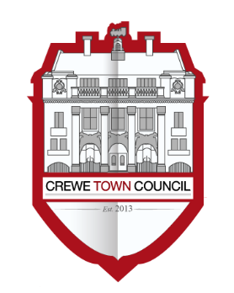
Crewe Town Council
Community Plan Committee
1 Chantry Court,
Forge Street,
Crewe,
Cheshire,
CW1 2DL
Tel: 01270 756975
www.crewetowncouncil.gov.uk

Minutes of the Meeting held on Monday 20th August 2018

18/2/01 | Present:-
 | Councillor Benn Minshall, Pam Minshall, Diane Yates and Simon Yates
 | Apologies:-
 | Councillors Damien Bailey, Suzanne Brookfield, Jill Rhodes and Dennis Straine-Francis
 | In attendance:-
 | Hannah Marr (Community Engagement Officer)
18/2/02 | To note declarations of Members’ interest
 | No declarations of interests were made by Members of the Community Plan Committee
18/2/03 | To confirm and sign the Minutes of the Community Plan Committee Meeting held on Monday 25th June 2018  (minutes attached)
 | The Minutes of the Community Plan Committee Meeting held on Monday 25th June 2018 were approved by Members and signed as an accurate record by the Chair of the Community Plan Committee
18/2/04 | To consider the Terms of Reference for the Community Plan Committee  (document attached)
 | Members considered the Terms of Reference for the Community Plan Committee and resolved that they be approved
18/2/05 | Public Participation
 | A period not exceeding 15 minutes for members of the public to ask questions or submit comments to the Community Plan Committee
 | No questions were raised or comments submitted by members of the public to the Community Plan Committee
18/2/06 | To note the financial position of the Community Plan Committee  (document attached)
 | Members noted the financial position of the Community Plan Committee
18/2/07 | To receive an update regarding the work undertaken by A Vision for Crewe – Crewe’s Community Plan  (document circulated)
 | Members received an update regarding the work undertaken by A Vision for Crewe – Crewe’s Community Plan from the Community Engagement Officer and the Chair of the Community Plan Committee
18/2/08 | To consider matters related to progressing the work undertaken by A Vision for Crewe – Crewe’s Community Plan under the themes of:-
- Arts, Culture, Leisure and Heritage
- Twinning and International Relations
- Health and Wellbeing
- Environment and Wildlife
- Young People and Families
- Education, Training, Volunteering and Employment
- Homeless and Vulnerable People
- Cheshire Neighbours Credit Union
- Supporting Community Organisations and Assets
- Raising Civic Pride
 | Members considered the proposed Crewe Friendship and Twinning Policy and resolved that it be adopted
 | Members further resolved to recommend to Council that Crewe Town Council enters into an Agreement regarding friendships or twinning arrangements with Mâcon, Dzierżoniόw and Bischofsheim at the earliest opportunity
 | Members considered the proposal regarding establishing Compassionate Communities Projects and requested that further information on costings was obtained which was then submitted to the Community Plan Committee at a later date
 | Members considered information submitted regarding the Visyon Community Ambassador Programme and resolved to support the project and the organisation with the Programme
 | Members considered the proposal regarding making Crewe Makaton Friendly and resolved to allocate funds to support a number of Makaton training sessions to support organisations and businesses in Crewe
 | Councillor Brian Roberts declared a non-pecuniary interest in Item 8H (Minute Reference: 18/2/08) relating to the Cheshire Neighbours Credit Union in light of being a Member of the Credit Union Board
 | Members considered the proposal from Cheshire Neighbours Credit Union and resolved to allocate funds of £2,300.00 to the Credit Union towards new and revised marketing materials
 | Members resolved that the Mayor of Crewe presents the Community Recognition Civic Award to a deserving member of the community
18/2/09 | To consider matters related to managing funds for an arts project should the bid submitted be successful
 | Members considered matters related to managing funds for an arts project and resolved to recommend to the Finance and Governance Committee that the Town Council acts as the responsible body should the bid be successful
18/2/10 | To consider matters related to the Royal Arcade hoardings subject to the necessary information being received prior to the Community Plan Committee Meeting
 | Members resolved to defer discussions on this Item due to the necessary information not being received prior to the Community Plan Committee Meeting
18/2/11 | To consider recommendations from the Grants Working Group in relation to applications submitted to the Crewe Town Council Small Grants Scheme before Sunday 5th August 2018
 | The Grant Application which have been submitted are:-
- Central Cheshire Buddies Scheme – £850.00
- St. Luke’s (Cheshire) Hospice – £1,009.08
- Find Your Voice CIC – £960.00
- Crewe Stroke Communication Club – £960.00
 | Members of the Community Plan Committee considered applications submitted to the Crewe Town Council Small Grants Scheme and:-
 | - An award of £850.00 was resolved to be made to Central Cheshire Buddies Scheme from the Crewe Town Council Small Grants Scheme
 | - An award of £1,009.08 was resolved to be made to St. Luke’s (Cheshire) Hospice from the Crewe Town Council Small Grants Scheme
 | - An award of £960.00 was resolved to be made to Find Your Voice CIC from the Crewe Town Council Small Grants Scheme
 | - An award of £960.00 was resolved to be made to Crewe Stroke Communication Club from the Crewe Town Council Small Grants Scheme
18/2/12 | To note the dates of future meetings of the Community Plan Committee
 | Members noted the dates of future meetings of the Community Plan Committee as:-
- Monday 1st October 2018
- Monday 3rd December 2018
- Monday 4th March 2019
 | Meeting closed at 8:27pm

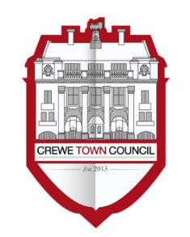
Crewe Town Council
Terms of Reference
Community Plan Committee 2018 / 2019

Purpose

The purpose of the Community Plan Committee is to oversee the delivery of A Vision for Crewe – Crewe’s Community Plan and support the delivery of improvements in the social lives of those who live, study, work or visit the Town

Functions and Remit

- Develop, facilitate and implement A Vision for Crewe – Crewe’s Community Plan to promote and improve the health, social and cultural wellbeing of those who live, work, study or visit the Town;

- To update the Community Plan as appropriate and seek Council approval for its adoption in any revised form;

- To administer and oversee the civic functions of the Town Council in conjunction with the Town Development Committee;

- To compile and submit responses to public consultations through the promotion and liaison with external stakeholders which are relevant to the work undertaken by A Vision for Crewe – Crewe’s Community Plan;

- To facilitate and support statutory, community, voluntary and faith sector organisations within the Town to deliver the aspirations of A Vision for Crewe – Crewe’s Community Plan;

- To have oversight of Working Groups formed to support special events, projects and assets in delivering the priorities set out in A Vision for Crewe – Crewe’s Community Plan;

- To develop, facilitate and implement matters related to community engagement through the support of community assets and organisations;

- To support partner organisations in the development and implementation of friendships, twinning arrangements and events;

- To administer the policies and procedures of the Council relating to grants and donations;

- To make and award grants and donations in accordance with Council policies and procedures;

- To have oversight of the Small Grants Scheme Working Group;

- To seek and maximise the benefit of external funding along with accepting and receiving grants and donations to support projects, events and activities;

- To receive and accept grants and donations from external parties to support the implementation and development of the work undertaken by A Vision for Crewe – Crewe’s Community Plan;

- To have oversight of the Council’s involvement with outside bodies which are relevant to the work undertaken by A Vision for Crewe – Crewe’s Community Plan;

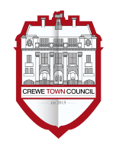
Crewe Friendship and Twinning Policy
Version 2

Background
Twinning was widely promoted after World War Two to engender reconciliation and build relationships. Although twinning per se may not meet the needs of modern generations, the notion of friendship still has relevance in today’s society. There are approximately 2,000 twinning arrangements in Britain and 75% are with French and German authorities

There is no fixed definition or model of town twinning or partnership arrangements. A twinning link is customarily defined as a friendship agreement involving co-operation between two communities in different countries, endorsed by both local authorities. The two twinned communities organise projects and activities around a range of issues and develop an understanding of historical, cultural and lifestyle similarities and differences. These activities should involve a wide range of community members and in keeping with any agreements which are in place

A ‘friendship’ can be seen as an affiliation between two communities that is considered and felt that it would be mutually beneficial to both parties

History of Twinning in Crewe
Crewe has been twinned with Mâcon, France, since 1957, and Dzierżoniόw, Poland, and Bischofsheim, Germany, since 1991

With the historical connection at its foundation, Crewe Town Council hopes to practicably and effectively establish a sustainable civic and community friendship with Mâcon, Dzierżoniόw and Bischofsheim

It will have the added value of strengthening relationships within Mâcon, Dzierżoniόw and Bischofsheim as the Town Council engages with community groups to plan and deliver friendship projects

The Purpose and Benefits of Twinning and Friendships
- Increasing cultural awareness, including knowledge and understanding of the places of origin and understanding of the places of origin of the town’s communities that can assist staff in their work and foster community cohesion;
- Instil a sense of community pride in Mâcon, Dzierżoniόw, Bischofsheim and Crewe;
- Broaden horizons in all of the towns through understanding cultural, linguistic and social exchanges;
- Provide opportunities for younger people to acquire new skills and contribute positively to a partnership between all towns;

Management
Crewe Town Council will formulate an official working relationship with the Crewe and Nantwich Twinning Association (CANTA) whereupon it will meet at regular intervals and submit reports of their activities to Crewe Town Council. Therefore, it is expected that at least one Councillor and one Officer will have the oversight of this function

5. Principles and Visions of Twinning and Friendship
To promote and celebrate the culture and heritage of Mâcon, Dzierżoniόw, Bischofsheim and Crewe through the following exchanges:-
  - Arts, Culture, Recreation and Heritage;
  - Twinning and International Relations;
  - Health and Wellbeing;
  - Environment and Wildlife;
  - Young People and Families;
  - Business and Enterprise;
  - Education, Training, Volunteering and Employment;
  - Vulnerable People;
  - Supporting Community Organisations and Assets;
  - To promote all towns and their surrounding areas as a place to be visited;

Whilst it is understood that Mâcon, Dzierżoniόw and Bischofsheim are of particular importance, the Town Council requests that more activity is focussed on promoting the cultural diversity of Crewe and that CANTA engages with residents who have settled in the Town from other countries

Funding and Review
Crewe and Nantwich Twinning Association will need to be self-funded

However, from time to time Crewe Town Council will make a financial contribution based on proposals submitted to the Community Plan Committee for the consideration of Councillors. Once any financial contribution is made then monies will be spent in accordance with agreed terms as stipulated by Crewe Town Council

The policy and all such agreement will be the subject of review on a periodical basis

Future scope
In order for twinning and friendships to survive, endure and become more relevant as society changes it is felt that the following aims and objectives must be considered and taken into account when organising activities, events and projects:-
- To encourage and increase levels of engagement and involvement in line with the principles and vision listed above;
- Increased awareness and knowledge of twinning and friendships within all towns;
- To proactively foster additional friendships with a view to entering into additional friendships;

Any future aims and objectives will be determined on the basis of how twinning and friendships develop in the interests of all parties

Compassionate Communities
Report to Community Plan Committee
Monday 20th August 2018

The End of Life Partnership (EoLP), through their Public Health and Wellbeing team (PHWB) have been working with communities across Cheshire since early 2013. We developed a Compassionate Communities model in 2017 working to prevent or reduce loneliness and social isolation. We are currently supporting seven towns and villages at various stages of creating their own compassionate community. By community we mean a group of people living/sharing the same place

Our definition of a Compassionate Community is fundamentally about working with communities rather than for them, by inspiring, enabling and empowering people to find their own solutions, build upon existing skills and knowledge, and by supporting each other in times of crises. We take a people centred, resident driven, strength based approach that is locally focused and is grassroots orientated

Our focus on supporting communities is due to 76,471 known unpaid carers throughout Cheshire. Loneliness and social isolation are major problems for adults with long term conditions and their informal carers. Interventions and activities aimed at reducing social isolation and loneliness are widely advocated as a solution to this growing problem (Gardener et al 2016). Our Pilot Community Chelford focussed on loneliness and social isolation of over 55’s, many of whom are living with long-term conditions, are carers or are bereaved

Our expertise lies in supporting communities to develop their own interventions and activities maintaining connections throughout aging and the last phase of life. We enable those who are living with long-term conditions or are approaching the end of their life and their relatives (unpaid carers) to maintain their connections and support networks. We nurture and train people in communities to develop their knowledge, skills and behaviours around life, age, death and loss

The activities that are making an impact to preventing loneliness and social isolation include:-
- Building local partnership working
- Training in the community around future life planning (wills, lasting power of attorney, funeral planning, unexpected death, advance care planning, etc.)
- Building knowledge, skills and confidence for people to support others and raise difficult conversations
- Building knowledge, skills and confidence around practically supporting each other
- Building upon existing social groups and how people can access these (access and advertising)
- Developing and facilitating new social groups and activities
- Facilitating the development of volunteer models such as buddying/befriending services, ‘Chelford Connectors’, ‘Street Rep’s’, social groups such as crafting memories, future life planning, Community Ambassadors, ‘friendly neighbours’ and developments similar to Senior Companion Programme (Butler 2006) and the ‘Call in Time’ programme (Cattan et al. 2011, Kime et al. 2012)
- Supporting the communities to act upon barriers that prevent people attending e.g. having a friendly face take them to a group for the first time, or giving someone a lift as transport is a barrier
- Carers Wellbeing Programme and bereavement training for community Volunteers

Compassionate Communities was identified within the Cheshire East Joint Strategic Needs Assessment (JSNA) 2017-2018 that highlighted the need to further ‘establish and enhance community development opportunities to support the needs of our local communities’ within their End of Life report

The Project emphasises a Public Health approach to end of life care. It encourages communities, including carers to support each other, and their families who are dying or living with loss and aims to enable people to live as well as they can. The project has been developed in response to the Dying Matters coalition (led by the National Council of Palliative Care 2010) and in line with the National Ambitions Framework for end of life and palliative care (2015) also of which is the basis for EoLP’s strategic plan. The Public Health Team’s objectives are based on Ambition 6 Each Community is prepared to help. To prepare communities we must enable, inspire and empower them by giving them the knowledge, skills and confidence around end of life issues in order for those communities to help each other in times of crises in life, age, death and loss.

Each community is different, however our main aim is to recognise the importance of tackling social isolation and loneliness among people with long term conditions and their Carers. For example, in the UK the Campaign to End Loneliness was established in 2011 as a network of national, regional and local organisations working together to ensure that loneliness is acted upon as a public health priority at national and local levels. Further studies (Mead et al (2010) showed that people who had taken on the responsibility of caring for a loved one with a long term condition were most at risk of loneliness and social isolation, as it prevented them from leaving their home.

To reach the people most at need the focus of the project will also benefit those that have been bereaved and others that present to professional and voluntary organisations as lonely and/or isolated. To identify those most at risk, we work in collaboration with general practices, local area coordinators, social care, Cheshire Carers Hub (and other carers organisations), Cheshire Police and Fire service, paramedics, paid care agencies, hospital staff and those in pastoral roles to refer to the community initiatives we support to establish. The project will also benefit those that volunteer and are part of the support networks, for example the volunteer befrienders in Chelford volunteered because they were lonely themselves and get so much from the volunteering process

EoLP Public Health Team have developed a Sustainable Compassionate Communities model that can be applied and is adaptable to suit differing Communities within Cheshire. The model is highlighted below:

Our approach:-

Discover and Assess –
- Identify local issues that could be supported through a Compassionate Community approach
- Asset map what is already out there –acknowledge the resources and connections developed through our extensive public health work over the last six years – this increased knowledge improves the referral processes of those feeling socially isolated, connecting them into relevant services and activities
- Give the community a voice- invite local people and community leaders from health and social care professionals, services such as libraries and schools, local charity representatives, activity, faith and community groups and local residents.

Focus and Commit –
- Analyse challenges and opportunities gained during ‘Discover and Assess’ by using data from local health centres, feedback from local residents and knowledge from these representatives, identify other activities to build on current provisions aimed at increasing access and connection – due to the extensive involvement and mapping, this means that no new activity duplicates or competes with already existing offerings
- Focus and prioritise on an area/s –set out a plan and include objectives short and long term, building further connections where needed

Build and Launch –
- Involve other community members to build momentum
- Educate the broader community about Compassionate Communities and acknowledge what is already happening within your community
- Launch a ‘kick start’ event –publicise the plan widely
- Begin the implementation of agreed action plan by bringing representatives from each of the participation groups together, to form a steering group to steer the direction based upon the needs of the community already identified
- Identify scope for volunteering as a way of increasing social connections within each community

Evaluate and Sustain –
- Monitor and measure progress and continue planning
- Celebrate successes, learn from unsuccessful efforts to inform future direction
- Communicate with the community on a regular basis and empower them to take further community development forward
- EoLP facilitate Communities to take the lead, take action for themselves and give them the confidence to build their own ideas for social connections. Each community will take a different approach as an example some communities may choose (through EoLP asset mapping sessions) to build a bank of volunteer befrienders that can support both the person with a long-term condition and their unpaid carer. This may be in the form of getting the person out and about, giving the carer some much needed time out, but can also be there to support through end of life planning and practicalities. The volunteer befrienders and Coordinator (trained by EoLP) can also provide support when caring ends and reconnect carers into the community and build up their social connections. We encourage communities to identify what they have and build upon this before tackling any gaps they have identified. This is the beginning of a sustainable model where the community starts within their own comfort zone. EoLP offer training and advice around end of life to the community to build their confidence further and prepare community members to tackle social isolation and loneliness around life, age, death and loss.

People in the communities can get involved in as much or as little as they are able. Some may offer buildings for clubs, some may be on the steering group, some may be able to provide transport or tea, and some local businesses may offer donations for refreshments at a carers group. The people in the community utilise their own knowledge and skills, and there is a sense of obligation for General Practices and services to get involved to understand the benefits of referring their patients (that are lonely and isolated) to the various social networks the community have chosen to focus on

By supporting the establishment of a steering group within the community (often made up from health, social care, church members, schools, parish councillors etc.) this group is then supported through EoLP facilitation to develop ideas for the future including knowledge about how to fund future initiatives, and developing a social isolation plan for the community

Visyon Community Ambassador Programme
Report to Community Plan Committee
Monday 20th August 2018

Who is Visyon?

Visyon is a mental health charity that supports young people when they most need it

Visyon provides a safe place for children, young people and their families to come to when they need help. Visyon are highly adept at working with young people to work out what’s troubling them and what they can do about it. Whether they’re confused, upset, worried, or feeling hurt or angry about something, somebody at Visyon is there to listen and help them to decide what they want to do next

Community Ambassador Programme

Visyon have recently launched a Community Ambassador programme where they aim to develop a team who will raise awareness of the issues affecting the emotional wellbeing of children and young people, and to engage the support of the community to tackle them

Community Ambassadors are drawn from all sections of the community and all age groups. Al they have in common is commitment to the emotional wellbeing of children and young people, and a willingness to do something about it

What does an Ambassador do?

The role is to take action in the community to promote the wellbeing of children and young people and support the work of Visyon

Request

Visyon needs help to recruit Ambassadors from local groups and businesses and has made a request to Crewe Town Council for their support to do so alongside a small amount of funding to facilitate the workshop and the materials needed for them

Making Crewe Makaton Friendly
Report to Community Plan Committee
Monday 20th August 2018

Introduction
This document outlines a proposal on how training and resources could be provided to deliver a basic level of Makaton across Crewe

It will cover:-
- The proposed vocabulary
- The Training Programme
- Ongoing Support
- Becoming Makaton Friendly
- Training Costs

This training works on the principle that each organisation would have a good number of staff complete the relevant Makaton Overview training

- Proposed Vocabulary
To ensure a good foundation vocabulary, the Makaton Charity ask we include 20 statutory words. These 20 words facilitate everyday interactions and are listed below

The Personalised Vocabulary would be agreed per area/group trained. This is typically another 15-20 signs plus the finger spelling alphabet. See some proposed but nor exhaustive ideas below
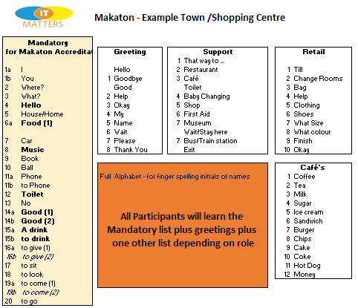

So for example staff in Cafés would attend training comprising of:-
- Mandatory Word List
- Greetings
- Café Words

As part of training the signs and symbols delivered are made available to attendees in a training handout to take away with them. See an example of a handout pack for medical staff

Costs do not include copies of the handouts but do include a Makaton Certificate and Makaton Badge per participant

- The Training Programme
The Makaton workshops each take between 120 minutes depending on the size of vocabulary taught

Participants would learn about signing with Makaton with the aim of them leaving with the confidence to Champion Makaton in their area of work

Each workshop agenda would look something like this:-
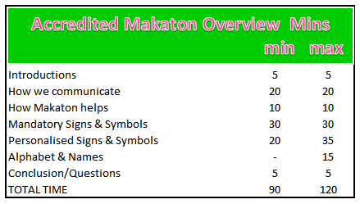

- Ongoing Support
IT Matters would be available to provide on-going support via email/telephone regarding clarity of signs/symbols and any new vocabulary required

The Makaton Charity also provide this support

Becoming Makaton Friendly
Once the site training is complete and embedded, we would be in a position to endorse an application to the Makaton Charity for Organisation to become Makaton Friendly. If around 30 Organisations meet the criteria then we can look to classifying Crewe as a Makaton Friendly Town. 30 Organisations with on average 5 people per organisation would be 150 people so approximately 8 training sessions

Once Makaton Friendly status is awarded you are licensed to use the Makaton Friendly logo and appear on the online Makaton Friendly map – see my former clients Alton Towers inclusion below as an example:
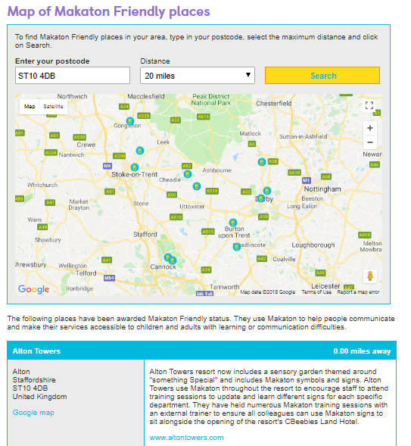
- Costs
An indication of costs, depending on number of sessions run is given here:
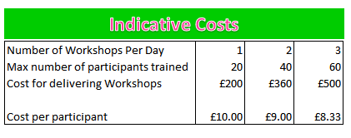
An example may be:

Day 1:
10.00-12.00 Workshop for Food and Drink Providers 20 People max
12.30-14.30 Workshop for Retail 20 People max
15.00-17.00 Workshop for Security/First Aid 20 People max

Day 2:
10.00-12.00 Workshop for Leisure/football 20 People max
12.30-14.30 Workshop for Cinema/theatre 20 People max
15.00 –17.00 Workshop for TBC 20 People max

Day 3:
10.00-12.00 Workshop for Leisure/football 20 People max
12.30-14.30 Workshop for Cinema/theatre 20 People max
15.00 –17.00 Workshop for TBC 20 People max

The training cost to deliver this would be £1,500

To be registered as Makaton Friendly there is an additional cost

The administration fee is £50 for organisations with under £1 million turnover and £100 for organisations with over £1 million turnover

Makaton Friendly is awarded for a period of 2 years

Cheshire Neighbours Credit Union
Report to Community Plan Committee
Monday 20th August 2018

Cheshire Neighbours Credit Union (CNCU) is a not-for-profit organisation run by a volunteer board, a small number of paid employees supported by a team of volunteers

CNCU is a financial co-operative which offers a genuine ethical alternative to High Street banks and loan companies. Just like its fellow credit unions throughout the world CNCU provides safe saving and competitive affordable credit to anyone who lives or works in Cheshire

Saving regularly allows one to work towards financial goals and can provide a cushion for the unforeseen financial emergency. Regular saving can reduce the need to borrow money from costly sources such as Payday Lenders and Loan Sharks

We accept not all in our communities can afford to make regular contributions to saving schemes when needing to make ends meet. To assist, CNCU offer a Budgeting Account, commonly known as a Jam Jar Account which offers a simple and convenient way of ensuring that priority bills are paid on time, and helps takes the stress out of paying essential bills and makes managing their finances easier

Since welfare changes were made and Universal Credit was introduced, many people have found themselves in arrears with rent or mortgage payments and council tax, etc.

Using a CNCU budget account is a great way to ensure all bills are paid on time

A CNCU budget account can be used for:-
- Rent and mortgage payments.
- Council tax.
- Gas, Electricity, Water bills.
- TV Licence payments.
- Other priority bills.

CNCU Budget Accounts work on a unique system called “Lock Down”cll, not offered by high street banks. The amounts for these essential bills to be paid is placed in a lock-down state until payment is made

This account can be funded through benefits, payroll deductions, wages, standing orders and direct debits

We see this a highly beneficial facility to assist many who:-
- Struggle to budget their money.
- Anyone who does not have a high street bank account.
- Tenants whose landlords need a secure payment method for rent.
- Local Authorities who require payment assurances for Council tax arrears.

We are in the process of upgrading our IT operating system to give greater flexibility in which to meet the needs of what can be quite complex and time consuming accounts, but never the less an essential service

CNCU operate from the 3rd floor of Delamere House, Crewe. This office accommodation is provided by CEC and although this is very welcome support, it leaves us with a lack of a “high street profile”

CNCU need to promote its many services which are available to all residents of Cheshire

To do this we have identified, following consultation with our members, staff and service users, and a number of actions we need to undertake to ensure the public in most need of these service are aware of their existence

It’s quite staggering how many people do not know we exist let alone how straight forward we are for them to access financial assistance available from us

It is essential for us to increase the awareness of our services in public places, such as medical and Connected Community Centres, benefit and council offices, work and leisure facilities, etc. As a precursor of this our literature needs to be updated along with our social media profile

Part of this information campaign will be to provide a comparison awareness between what is on offer by CNCU compared to the highly inflated and extortionate charges made by the weekly payment stores for essential domestic appliances and furnishings such as washing machines, beds and sofas, etc.

To do this we are looking for the support of Crewe Town Council to help us to fund the design and printing of posters and leaflets to place in the identified locations and to create a new Social Media Profile

Approximate costs subject to design update and quantities
for leaflets and posters we estimate would be £1300

Specialist “Landlords” leaflet £350

Design and placing of Social Media Profile £650

Total £2,300

We feel our proposal meets the criteria of the Vision for Crewe and of the CTC community Plan

Raising the awareness in Crewe and the greater area of Cheshire East will enable residents to access an established financial assistance service where they can be provided with help in managing their financial problems and maintain their household requirements at an affordable and sustainable level

Successful Debt Management can play a major role in relieving of stress and improving the health and wellbeing of all members of a household. Providing affective means of managing household expenses can prevent the more vulnerable in our communities from falling deeper into debt and despair

Should the Community Plan Committee grant our request we would be very pleased to ensure the CTC support is recognised on the publication

Councillor Brian Roberts entered the Community Plan Committee Meeting at the beginning of this Item

