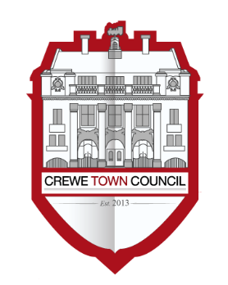
Crewe Town Council
Community Plan Committee
1 Chantry Court,
Forge Street,
Crewe,
Cheshire,
CW1 2DL
Tel: 01270 756975
www.crewetowncouncil.gov.uk

Minutes of the Meeting held on Monday 25th June 2018

18/1/01 | Present:-
 | Councillors Suzanne Brookfield, Benn Minshall, Jill Rhodes, Brian Roberts, Diane Yates and Simon Yates
 | Apologies:-
 | Councillor Damien Bailey and Pam Minshall
 | In attendance:-
 | Hannah Marr (Community Engagement Officer)
18/1/02 | To elect a Chair of the Community Plan Committee
 | Members resolved to elect Councillor Benn Minshall as the Chair of the Community Plan Committee
18/1/03 | To elect a Vice Chair of the Community Plan Committee
 | Members resolved to elect Councillor Jill Rhodes as the Vice Chair of the Community Plan Committee
18/1/04 | To note declarations of Members’ interests
 | Councillor Brian Roberts declared a non-pecuniary interest in Item 9 (Minute Reference: 18/1/09) relating to projects taking place at Edleston School in light of being a Governor of the School
 | Councillor Jill Rhodes declared a non-pecuniary interest in Item 9 (Minute Reference: 18/1/09) relating to projects taking place at St. Andrew’s Church in light of being a member of the congregation
 | Councillor Suzanne Brookfield declared a non-pecuniary interest in Item 9 (Minute Reference: 18/1/09) relating to the proposed projects being planned at Monks Coppenhall Academy in light of being Trustee of the School
 | Councillor Brian Roberts declared a non-pecuniary interest in Item 10H (Minute Reference: 18/1/10) relating to the Cheshire Neighbours Credit Union in light of being a Member of the Credit Union Board
 | Councillor Jill Rhodes declared a non-pecuniary interest in Item 11F (Minute Reference: 18/1/11) relating to the grant application for St. Andrew’s Church in light of being a member of the congregation
 | Councillor Brian Roberts declared a non-pecuniary interest in Item 11G (Minute Reference: 18/1/11) relating to the grant application for CHANCE Changing Lives in light of being a Trustee of the Charity
 | In the interest of transparency, Members of the Community Plan Committee wished that it be noted that they have an association with CHANCE Changing Lives and Crewe junior parkrun
18/1/05 | To confirm and sign the Minutes of the Community Plan Committee Meeting held on Tuesday 27th March 2018  (minutes attached)
 | The Minutes of the Community Plan Committee Meeting held on Tuesday 27th March 2018 were approved by Members and signed as an accurate record by the Chair of the Community Plan Committee
18/1/06 | To consider the Terms of Reference for the Community Plan Committee  (document attached)
 | Members considered matters related to the Terms of Reference for the Community Plan Committee

Members resolved to recommend to Council that the following be added to the Terms of Reference for the Community Plan Committee:-
- That the Committee has oversight of the Council’s involvement with outside bodies which are relevant to the work undertaken by A Vision for Crewe – Crewe’s Community Plan such as the Crewe Pledge;
- That the Committee administers and oversees the civic function of the Council in conjunction with the Town Development Committee;
- That the Committee compiles and submits responses to public consultations through promotion and liaison with external stakeholders which are relevant to the work undertaken by A Vision for Crewe – Crewe’s Community Plan;
18/1/07 | Public Participation
 | A period not exceeding 15 minutes for members of the public to ask questions or submit comments to the Community Plan Committee
 | No questions were asked or comments submitted to the Community Plan Committee by members of the public
18/1/08 | To note the financial position of the Community Plan Committee  (document attached)
 | Members noted the year to date financial position of the Community Plan Committee
18/1/09 | To receive an update regarding the work undertaken by A Vision for Crewe – Crewe’s Community Plan  (document circulated)
 | Members received an update regarding the work undertaken by A Vision for Crewe – Crewe’s Community Plan from the Community Engagement Officer
18/1/10 | To consider matters related to progressing the work undertaken by A Vision for Crewe – Crewe’s Community Plan under the themes of:-  - Arts, Culture, Recreation and Heritage (covered in Item 9 document)  - Twinning and International Relations (document circulated)  - Health and Wellbeing (covered in Item 9 document)  - Environment and Wildlife (document circulated)  - Young People and Families (document circulated)  - Education, Training, Volunteering and Employment (covered in Item 9 document)  - Homeless and Vulnerable People (covered in Item 9 document)  - Cheshire Neighbours Credit Union (covered in Item 9 document)  - Supporting Community Organisations and Assets (covered in Item 9 document)  - Raising Civic Pride (covered in Item 9 document)

Members considered matters related to progressing the work undertaken by A Vision for Crewe – Crewe’s Community Plan under the themes of:-
- Arts, Culture, Recreation and Heritage
- Twinning and International Relations
- Health and Wellbeing
- Environment and Wildlife
- Young People and Families
- Education, Training, Volunteering and Employment
- Homeless and Vulnerable People
- Cheshire Neighbours Credit Union
- Supporting Community Organisations and Assets
- Raising Civic Pride

Councillor Simon Yates updated the Community Plan Committee with regards to the current status of international twinning and friendships with Crewe and the Council’s relationship with Crewe and Nantwich Twinning Association (CANTA)

Councillor Dennis Straine-Francis declared a non-pecuniary interest in this item in light of being a member of Crewe and Nantwich Twinning Association

Members resolved to adopt the Crewe Friendship and Twinning Policy presented to the Community Plan Committee and wished it be noted that the Town Council is keen to develop new relationships as well as continuing the links already established with Mâcon in France, Dzierżoniόw in Poland and Bischofsheim in Germany

Councillor Simon Yates advised Members that an approach had been made by Mâcon to attend the Crewe Remembrance Sunday and the centenary activities commemorating World War One in November 2018 with the view that a reciprocal arrangement will be made to visit Mâcon.

The Community Engagement Officer advised Members that pupils from Edleston School will be writing letters to students at Szkoła Podstawowa nr 9 in Dzierżoniόw with the view of becoming pen friends and developing links international connections with young people
 | Members resolved to accept the Environment Crewe branding and to establish a project to engage with community organisations to recognise their activities relating to environment and wildlife and support them to develop new initiatives
 | Members considered a proposal from junior parkrun to establish a junior parkrun in Crewe and requested that further information was obtained which can then be considered at a future meeting of the Community Plan Committee
 | Councillor Simon Yates updated the Community Plan Committee on the recent Crewe Homeless Working Group Meeting and a subsequent meeting with Cheshire East Council regarding their bid to the Ministry of Housing
18/1/11 | To consider recommendations from the Grants Working Group in relation to applications submitted to the Crewe Town Council Small Grants Scheme submitted to the Town Council before Sunday 10th June 2018
 | The Grant Applications which have been submitted are:-
- On Your Marks CIC – £1,000.00
- Sporting Communities CIC – £1,000.00
- The Lighthouse Centre – £1,000.00
- 95 Squadron (Crewe) Air Cadets – £1,000.00
- Action On Cancer – £1,000.00
- St. Andrew’s Church – £250.00
- CHANCE Changing Lives – £1,000.00

(grant applications circulated)
 | Members of the Community Plan Committee considered applications submitted to the Crewe Town Council Small Grants Scheme and:-
 | - An award of £1,000.00 was resolved to be made to On Your Marks CIC from the Crewe Town Council Small Grants Scheme
 | - An award of £1,000.00 was resolved to be made to Sporting Communities CIC from the Crewe Town Council Small Grants Scheme
 | - An award of £1,000.00 was resolved to be made to The Lighthouse Centre from the Crewe Town Council Small Grants Scheme
 | - An award of £1,000.00 was resolved to be made to 95 Squadron (Crewe) Air Cadets from the Crewe Town Council Small Grants Scheme
 | - An award of £1,000.00 was resolved to be made to Action On Cancer from the Crewe Town Council Small Grants Scheme
 | - An award of £250.00 was resolved to be made to St. Andrew’s Church from the Crewe Town Council Small Grants Scheme
 | - An award of £1,000.00 was resolved to be made to CHANCE Changing Lives from the Crewe Town Council Small Grants Scheme
18/1/12 | To note the dates of future meetings of the Community Plan Committee
 | - Monday 20th August 2018
 | - Monday 1st October 2018
 | - Monday 3rd December 2018
 | - Monday 4th March 2019
18/1/13 | The Meeting of the Community Plan Committee was formally closed at 20:17pm

Crewe Town Council
Terms of Reference
Community Plan Committee
Monday 25th June 2018

The purpose of this Committee is to:-

Oversee the delivery of A Vision for Crewe – Crewe’s Community Plan and support the delivery of improvement of the lives of those who live, work and visit the town of Crewe

The functions and remit of the Community Plan Committee are to:-

- Develop, facilitate and implement A Vision for Crewe – Crewe’s Community Plan to promote and improve the health, social and cultural wellbeing of those who live, work, study and visit the town of Crewe

- To update the Community Plan as appropriate and seek Council approval for its adoption in any revised form

- To administer and oversee the civic function of the Town Council

- To compile and submit responses to public consultations through promotion and liaison with external stakeholders

- To facilitate and support statutory, community, voluntary and faith sector organisations within the town to deliver the aspirations of A Vision for Crewe – Crewe’s Community Plan

- To have oversight of Working Groups formed to support special events, projects and assist delivering the priorities set out in A Vision for Crewe – Crewe’s Community Plan

- To develop, facilitate and implement matters related to community engagement through support for community assets

- To support partner organisations in the development and implementation of local friendships, twinning arrangements and events

- To have oversight of the Grants Working Group

- To administer the policies and procedures of the Council relating to grants and donations

- To make and award grants and donations in accordance with Council policies and procedures

- To seek and maximize the benefit of external funding along with accepting and receiving grants and donations to support projects, events and activities

- To receive and accept grants and donations from external parties to support the implementation and development of A Vision for Crewe – Crewe’s Community Plan

Membership of the Community Plan Committee shall consist of ten elected members including the Mayor and Deputy Mayor supplemented by lay members, under Standing Order 15iii, and subject to approval of Council. External parties shall not take office without completing a Declaration of Interest form and membership of the Committee will be subject to review at Annual Council

The quorum of the Community Plan Committee shall be four elected members

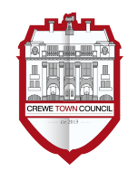
Crewe Friendship and Twinning Policy
Version 1

Background
Twinning was widely promoted after World War Two to engender reconciliation and build relationships. Although twinning per se may not meet the needs of modern generations, the notion of friendship still has relevance in today’s society. There are approximately 2,000 twinning arrangements in Britain and 75% are with French and German authorities

There is no fixed definition or model of town twinning or partnership arrangements. A twinning link is customarily defined as a friendship agreement involving co-operation between two communities in different countries, endorsed by both local authorities. The two twinned communities organise projects and activities around a range of issues and develop an understanding of historical, cultural and lifestyle similarities and differences. These activities should involve a wide range of community members and in keeping with any agreements which are in place

A ‘friendship’ can be seen as an affiliation between two communities that is considered and felt that it would be mutually beneficial to both parties

History of Twinning in Crewe
Crewe has been twinned with Mâcon, France, since 1957, and Dzierżoniόw, Poland, and Bischofsheim, Germany, since 1991

With the historical connection at its foundation, Crewe Town Council hopes to practicably and effectively establish a sustainable civic and community friendship with Mâcon, Dzierżoniόw and Bischofsheim

It will have the added value of strengthening relationships within Mâcon, Dzierżoniόw and Bischofsheim as the Town Council engages with community groups to plan and deliver friendship projects

The Purpose and Benefits of Twinning and Friendships
- Increasing cultural awareness, including knowledge and understanding of the places of origin and understanding of the places of origin of the town’s communities that can assist staff in their work and foster community cohesion;
- Instil a sense of community pride in Mâcon, Dzierżoniόw, Bischofsheim and Crewe;
- Broaden horizons in all of the towns through understanding cultural, linguistic and social exchanges;
- Provide opportunities for younger people to acquire new skills and contribute positively to a partnership between all towns;

Management
Crewe Town Council will formulate an official working relationship with the Crewe and Nantwich Twinning Association (CANTA) whereupon it will meet at regular intervals and submit reports of their activities to Crewe Town Council. Therefore, it is expected that at least one Councillor and one Officer will have the oversight of this function

5. Principles and Visions of Twinning and Friendship
- To promote and celebrate the culture and heritage of Mâcon, Dzierżoniόw, Bischofsheim and Crewe through the following exchanges:-
  - Arts, Culture, Recreation and Heritage;
  - Twinning and International Relations;
  - Health and Wellbeing;
  - Environment and Wildlife;
  - Young People and Families;
  - Business and Enterprise;
  - Education, Training, Volunteering and Employment;
  - Vulnerable People;
  - Supporting Community Organisations and Assets;
  - To promote all towns and their surrounding areas as a place to be visited;

Funding and Review
Crewe and Nantwich Twinning Association will need to be self-funded

However, from time to time Crewe Town Council will make a financial contribution based on proposals submitted to the Community Plan Committee for the consideration of Councillors. Once any financial contribution is made then monies will be spent in accordance with agreed terms as stipulated by Crewe Town Council

The policy and all such agreement will be the subject of review on a periodical basis

Future scope
In order for twinning and friendships to survive, endure and become more relevant as society changes it is felt that the following aims and objectives must be considered and taken into account when organising activities, events and projects:-
- To encourage and increase levels of engagement and involvement in line with the principles and vision listed above;
- Increased awareness and knowledge of twinning and friendships within all towns;
- To proactively foster additional friendships with a view to entering into additional friendships;

Any future aims and objectives will be determined on the basis of how twinning and friendships develop in the interests of all parties

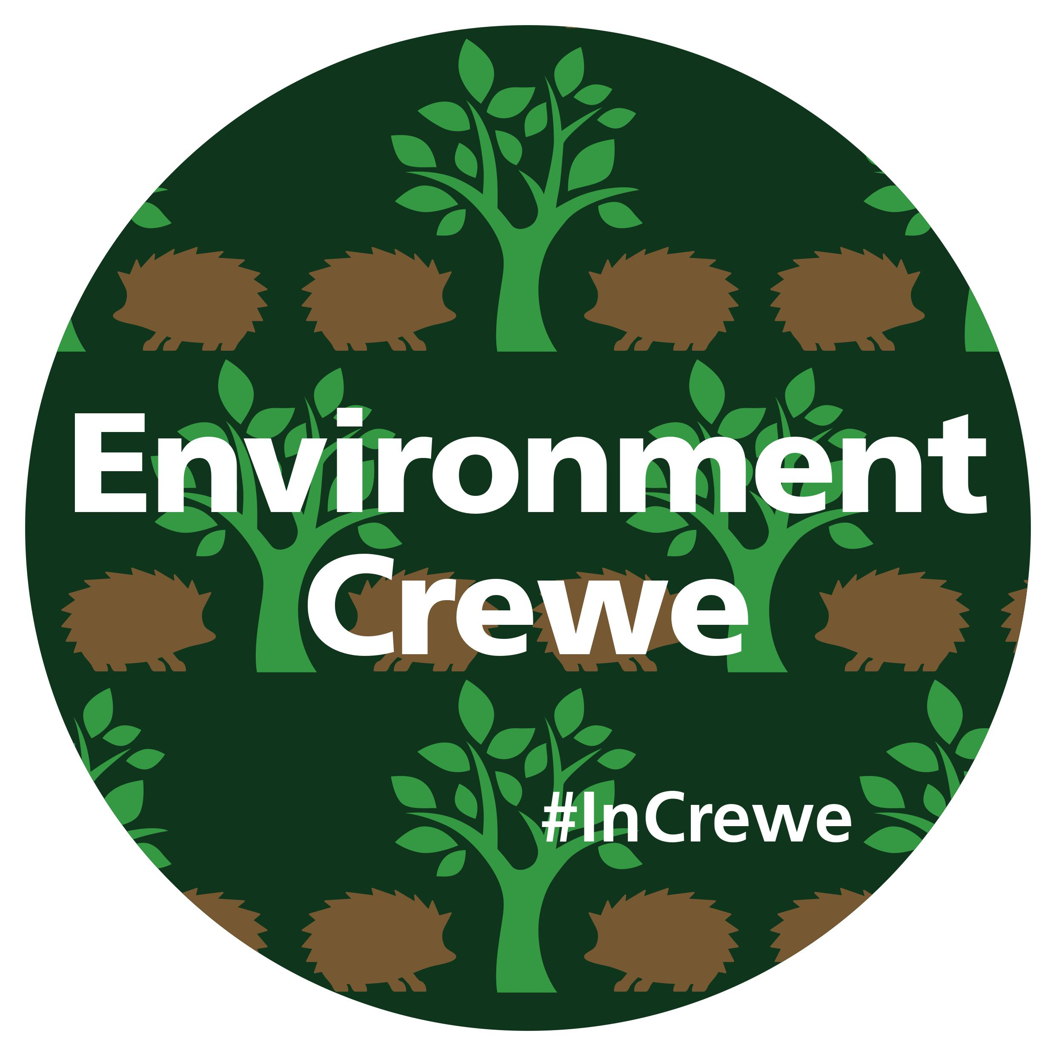

Crewe junior parkrun Proposal
Report to Community Plan Committee
Monday 25th June 2018

What is junior parkrun?

Launched in February 2018, Crewe parkrun is a 5 kilometre run which takes place on a Saturday morning for adults (but some children do take part) and it distinctly demonstrates how these events positively contribute towards community spirit, improves people’s health and fitness directly and indirectly and is a great use of Queen’s Park

Junior parkrun is a series of 2 kilometre events aimed at young people aged between 4 and 14 years old. These events are open to all abilities, free to access, safe and definitely easy to take part in. Junior parkruns take place on a Sunday morning and there are currently over 210 taking place across the United Kingdom

The closest junior parkruns to Crewe are Northwich, Wilmslow and Widnes. All boast impressive turnouts and there is an overwhelming amount of enthusiasm and support for children, parents and local authorities – Northwich averages 70 runners each week, Wilmslow average 84 and Widnes 76. The weekly numbers continue to grow as the event raises its profile and they will within a matter of weeks, reach over 100 runners every week

Funding requirements

It costs parkrun UK £6,000 to set up a parkrun event. However, they are able to cover half the set up costs and all the running costs once the run starts

We would therefore like to approach Crewe Town Council with an ask of £3,000 to help find the remainder of the set up costs which will enable us to establish the Crewe junior parkrun as soon as possible

Benefits to the community

We feel the Crewe community will really benefit from a junior parkrun in the following ways:-
- Increase enthusiasm for sports, activity participation and healthy lifestyles in children and young people
- Provide a safe and fun environment for children and young people between 4 and 14 years old to participate in
- Provide inclusive opportunities for children and young people with disabilities to participate in as the course is fully accessible and everyone can complete the course at their own pace
- Provide a supportive, low stress environment for children who may struggle with team sports, or feel under pressure in other club environments
- Encourage independence the young people who take part can run the course themselves and achieve their running times at their own volition
- Opportunity for families to take part together – although adults do not get their times recorded, they can run alongside their children and it allows families to form a closer bond as well as additional friendships within the community in which they live
- Increase appreciation, and respect, for the natural environment e.g. the park, the ecosystem, etc.
- Showcase the beautiful Queen’s Park to both local and national parkrun participants. As with the 5 kilometre adult parkrun, runners from all over the country travel to participate in the different parkrun locations
- Consolidate and build skills and experience associated with volunteering within the community

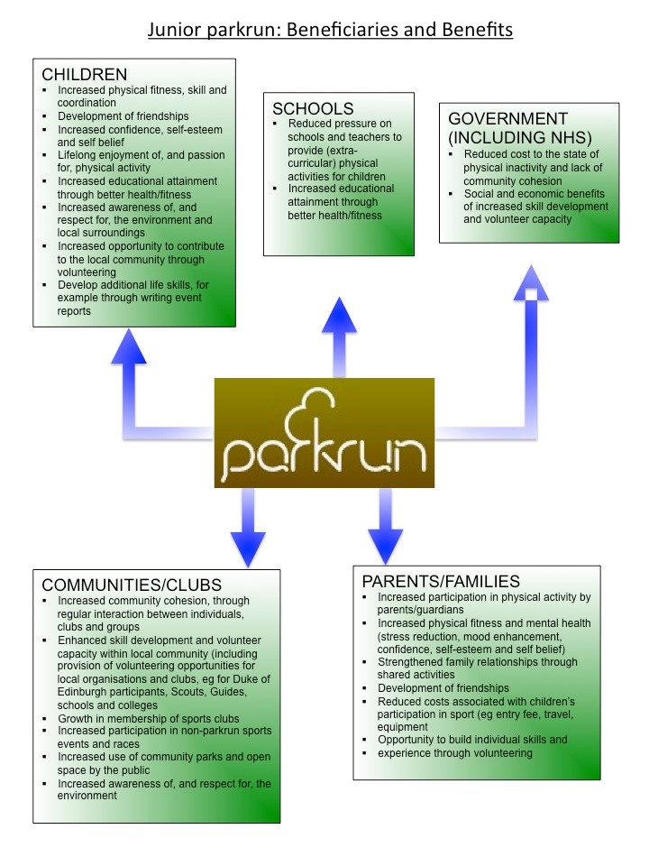

Councillor Dennis Straine-Francis joined the meeting at the beginning of Item 10 (Minute Reference: 18/1/10)

